20th April
First Class – Mrs Gallagher
Hi all,
I hope you are having a chance to enjoy the lovely weather. Now that the Easter holidays are over and all the eggs are eaten, we had better get some more work done.
Remember to do what you can and don’t be worrying about what you can’t do. I know that you are all very eager to be working Keep doing lots of chores for your parents and be kind to your brothers and sisters.

Reading –parents can register free on this site https://home.oxfordowl.co.uk/ you will be able to access free e books at your child’s level. Select a book and if it’s too difficult choose another one. Or simply use a book from home and practice reading it.

Spellings- This week’s spellings are the ou,ow sounds
out,how,brown, now,cow,shout,sound, down, loud,clown, owl, town, count, outside, house, and mouse.
Mammies or Daddies can test them on Friday and give them a treat when they finish.

Poetry- Buttercups and Daises

Irish – Why not get the children to count to 10 as gaeilge,
- 1 = a haon (ah hain)
- 2 = a dó (ah dough)
- 3 = a trí (ah tree)
- 4 = a ceathair (ah cah-her)
- 5 = a cúig (ah coo-ig)
- 6 = a sé (ah shay)
- 7 = a seacht (ah shocked)
- 8 = a hocht (ah huck-t)
- 9 = a naoi (ah nay)
- 10 = a deich (ah deh

Say the days of the week in Irish

- Monday - An Luan.
- Tuesday - An Mháirt.
- Wednesday - An Chéadaoin.
- Thursday - An Déardaoin.
- Friday - An Aoine.
- Saturday - An Satharn.
- Sunday - An Domhnach.

Cé hé/hí sin? Sin é/í________.
Cé tusa? Is mise__________.
Bí ag léim,ag siúl,ag rith, ag sugradh, ag máirseáil
Ná bí ag rith

SESE- Explore with me -The Ugly Duckling pg. 45. Discuss the story and put in order
- use your Kiddle ( child friendly Google) to research the swan or duck, write a little report about it and draw a picture / diagram of it and label the parts of the swan, duck

Maths – keep giving the children a block of maths daily pg. 60,61,
This week why not practice the time by making a clock from card and asking them to show the time, o clock, and half past
They can be counting to 100, forwards and backwards, count up in 2’s and 5’s and 10’s. They can tell you all the odd numbers and even numbers
Planet maths pages 108,109,110,111,119 Why not do one page every day and space it out

Handwriting. Practice away on blank paper or spare copies. Take one page every day from your book. Give them lots of opportunity to practice their writing by using crayons, pens, pencils markers etc. letting them have fun with it.
Art –
Find some butterflies and daises from the garden to go with your poem, draw the flowers on a page and label the parts of your flower, stem, petal, leaves and seeds

Language
Word Wise - phonics pg 44, capital i pg 45 and comprehension pg 50 and 51 .Children can practice writing ub,un,ub,um,ug words into their hardback copies and can make silly words with theses combinations also.

Exercise your English – comprehension and reading skills pages 66 and 67.
Poem My little dogs on page 64

Our class e mail address is firstclass.steunans@gmail.com
And remember you can send pictures and videos to the class e mail of any activities that your child is doing or if you have any questions. I really enjoyed receiving e mails back from the children, thank you!!!

Good luck with all the work and God bless.
Kind regards
Mrs Gallagher

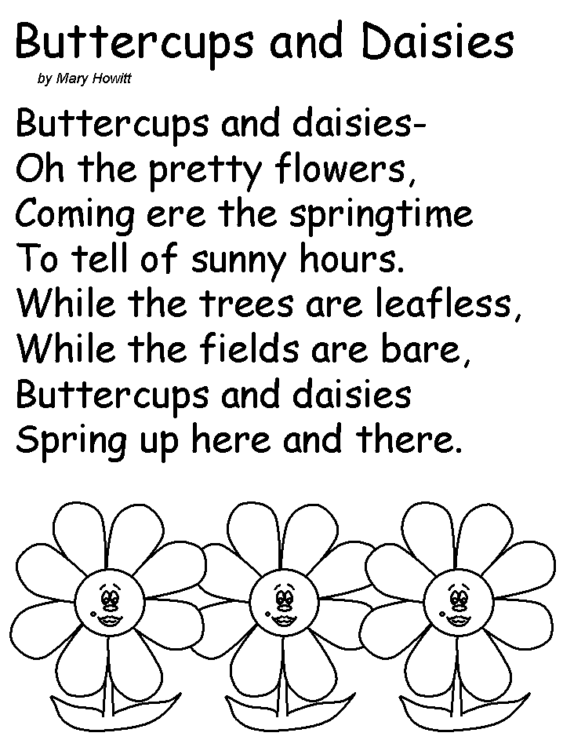
Mrs McCaffrey has sent an e mail containing all her work to all her pupils.
If you have not furnished the school with your e-mail could you please do so as soon as possible so that she can send out work to your child and we can keep in touch with you.
Many thanks.

