Work List For Week Starting 20th April

I hope you all had a great Easter and got lots of chocolate eggs. I don’t expect all of this work completed. These are ideas for you. I hope you are all doing well.

English
Reading- Library Books and OXFORD OWL
Spellings
Pandemic, closures, tutoring, baking, gardening, building, communicate, headlines, restrictions, precautions, hand hygiene, respiratory, transmitting, cocooning, lockdown, cough, health, Covid 19,
Coronavirus.
Look up words. Some of the words may not be in the dictionary.
Write a page to tell me any thing exciting that you have been doing and send a picture too.

Maths
Tables- continue to learn multiplication tables. If multiplication tables are mastered move on to the Division Tables. If not stick with multiplication tables.
Multiplication sums – continue to practise
3rd Class
345 x5 834 x 7 254 x 8 398 x 9 543 x 3 458 x 3 723 x 6 392 x 9
4th Class
862 x 54 926 x 23 876x 35 453 x67 234 x 78 326 x56 238 x 83
Decimals (see chapter in Planet Maths – Planet Maths can be accessed on folensonline. Page 61
Rules : To change a fraction to a decimal, you need 10, 100 or 1000 at the bottom of the fraction.
We start with trying to get 10.
If you have 10 objects you can make tenths easily. Put your number over 10. Example if you have 7 oranges and 3 apples Oranges =7/10 Apples = 3/10.
Changing fractions to decimals – if your fraction is over 10, you should have one number after the decimal point. Example 4/10 = 0.4
You need 10/10 to make a whole number. Example 14/10 = 1.4
4th Class – You will also work on fractions over 100 (If this is hard go to the Planet Maths 3 book on folens online and revise decimals in it first)
If your fraction is over 100 you will have 2 numbers after the decimal point Example 2/100 =0.02
36/100=0.36 41/100=0.41 7/100 =0.07 123/100 =1.23

3rd and 4th Class – It is important to Revise Fraction Facts – Fractions Equivalence 2/10 = 1/5 4/10 = 2/5 6/10 =3/5 8/10 =4/5 10/10 = 5/5
½ = 5/10
Comparing Decimals
Look at the whole number first and then the tenths and then hundredths.

Gaeilge
See page “I have a pain” attached for spellings
See attached “Seo Mo Chorp” song
Try to make 4 sentences about what you did this morning. Use your Aimsir Caite. Short sentences.
Continue on with Irish Reading.

Science
The Respiratory System- Some youtube Clips
https://www.youtube.com/watch?v=rUVMok4Qp-Y

https://www.youtube.com/watch?v=mOKmjYwfDGU

Making Lungs
https://www.sfi.ie/site-files/primary-science/media/pdfs/col/lungs_activity.pdf
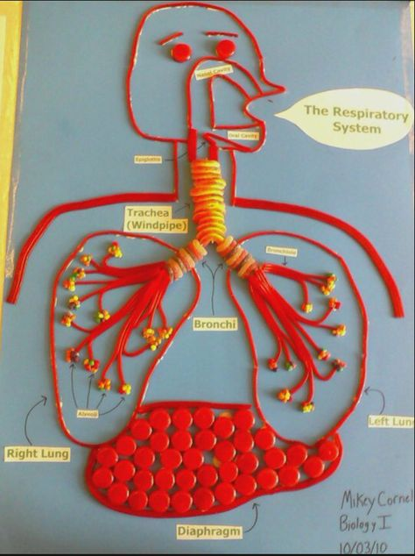
Safety Careful cutting the bottle. Children will need help

Making an apron of the Respiratory
System.

Geography
https://www.kids-world-travel-guide.com/italy-facts.html
Find out about Italy
Maybe have an Italian Day. Make the Italian Flag, Eat Pizza or Pasta, Study the Map, Use a few Italian Words, Play Football- the Italians love their Football, Make a model of Mt Etna in Sicily or any of the Famous Landmarks.

SPHE
Safety and Protection – Hygiene
Make a poster to communicate Hand Washing or Stay At Home or Cough Hygiene.
Send them to me to post on Facebook

Music
Listen to Italian music on youtube and draw a scene from a famous Italian Landmark.

Art
Put you picture into a frame made from pasta shapes

History
Interview a grandparent/ parent about games they used to play in the past
Questions
What were your favourite games to play?
Who did you play with?
Where did you play these games?
Did you have any special toys?
Can you describe how to play a few of the games you played?

- Draw a picture of a game you liked the sound of.
- Why not try it out at home.

Research 5 Facts about the Romans

Religion
Story of Doubting Thomas
Begin to say the Rosary.
