Mrs Keeve’s Work List 25th May
Hello Everyone,
Around this time every year we have activities relating to the outdoor classroom. This week we are basing our learning on the great outdoors. Try as much as you can to get outside and enjoy all the wonderful learning in nature. This is a list to help you. It is not expected that everything on this list would be completed.

English
Spellings- relating to maths. Learning to spell these words should help children when they see them written in a maths question. Also, some outdoor words are included, and the children could look them up in their dictionaries.
cube, pyramid, cylinder, sphere, cone, rectangular prism, triangular prism, hemisphere, cuboid, faces, edges, vertices, environment, weather, recycling, climate, habitat, wildlife, foliage
Reading

The Swing
By Robert Louis Stevenson
How do you like to go up in a swing,
Up in the air so blue?
Oh, I do think it the pleasantest thing
Ever a child can do!
Up in the air and over the wall,
Till I can see so wide,
River and trees and cattle and all
Over the countryside--
Till I look down on the garden green,
Down on the roof so brown--
Up in the air I go flying again,
Up in the air and down!
Continue to read library books and www.oxfordowl.co.uk.

Writing
Put on your creative thinking hats and write a funny caption, quote, or story to go with these pictures.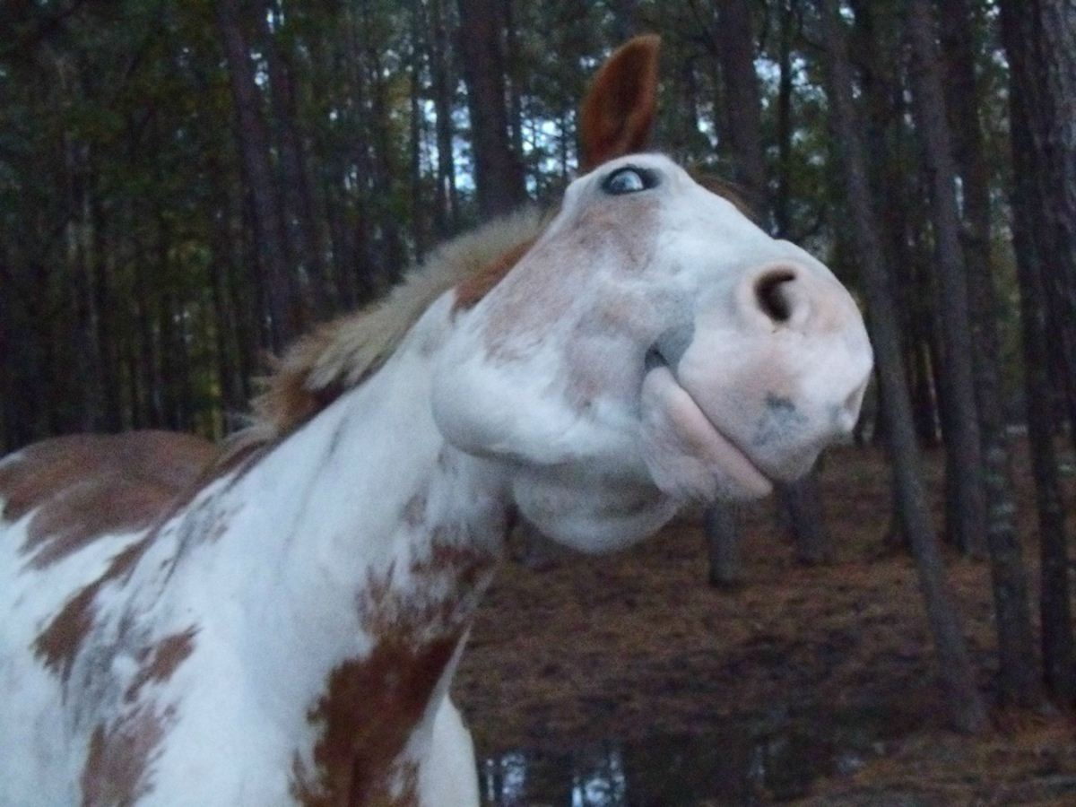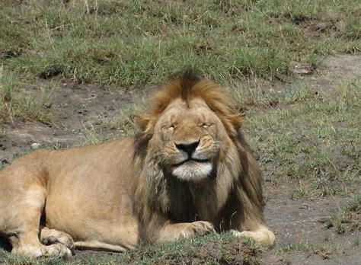
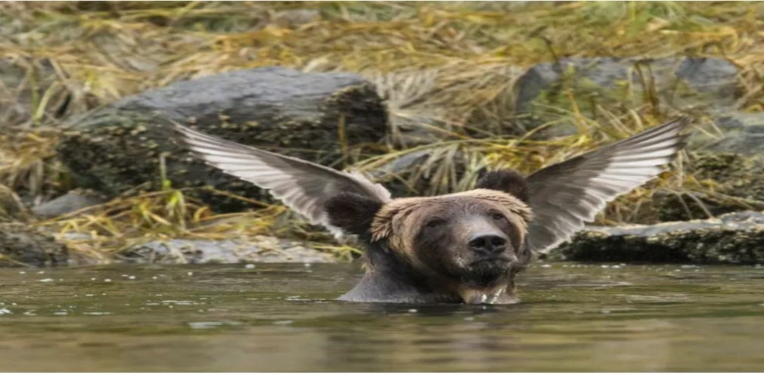
Have a talk about them with your family.

Oral Language
Discuss these outdoor idioms and times they can be used.
once in a blue moon
Meaning: very rarely
Example: I go to visit my grandfather only once in a blue moon; he lives on a remote farm house.

a bed of roses
Meaning: easy option
Example: Taking care of my younger sister is no bed of roses; she is very silly.

apple of eye
Meaning: someone very precious or dear
Example: Every kid in the world is the apple of their parents' eye(s).

raining cats and dogs
Meaning: raining very heavily
Example: I wanted to go to play outside, but it was raining cats and dogs

when pigs fly
Meaning: something that will never happen or is impossible.
Example: William will keep quiet only when pigs fly.

miss the boat
Meaning: miss the chance.
Example: Peter wanted to enter the drawing competition, but he was too late to enter, and he missed the boat.

Maths
This week we will look at 3D shapes, however for a few weeks I will continue to give the children division work also.
Some 3D Shapes – Learn their names.

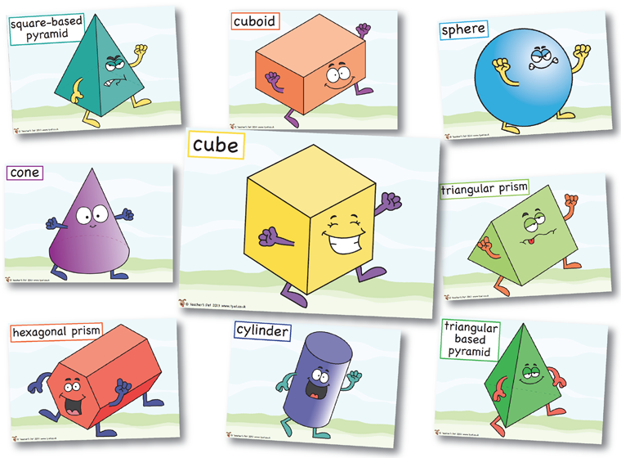

https://www.youtube.com/watch?v=2cg-Uc556-Q

I would like you to go on a 3D Shape Treasure Hunt at home. It would be even better if you could find some 3D Shapes outside. If you do, you could send your picture to the facebook page.
Properties of 3D Shapes
- Faces are the surfaces that make up the outside of a shape.
- Edges are the lines in between the faces.
- Vertices (or corners) are where two or more edges meet.
Vertex is singular and vertices is plural. Same thing.
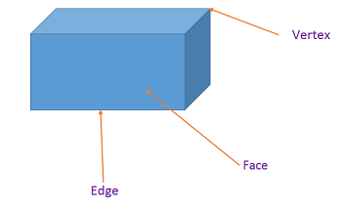
These are the nets of some 3D Shapes. To investigate their properties, we take 3D shapes apart and flatten them down. We can clearly see how many faces, vertices and edges each 3 D Shape has. Using the nets, you could try and build your own 3D Shapes.
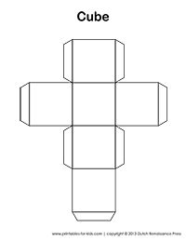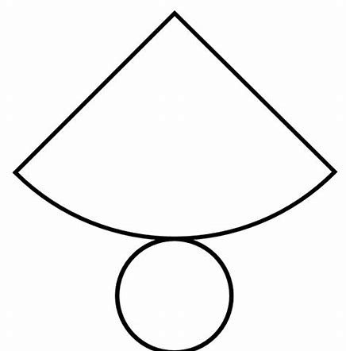Cone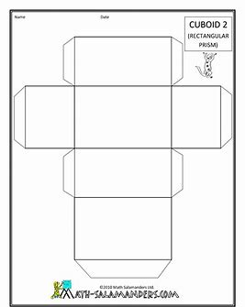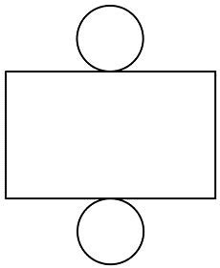

Cylinder

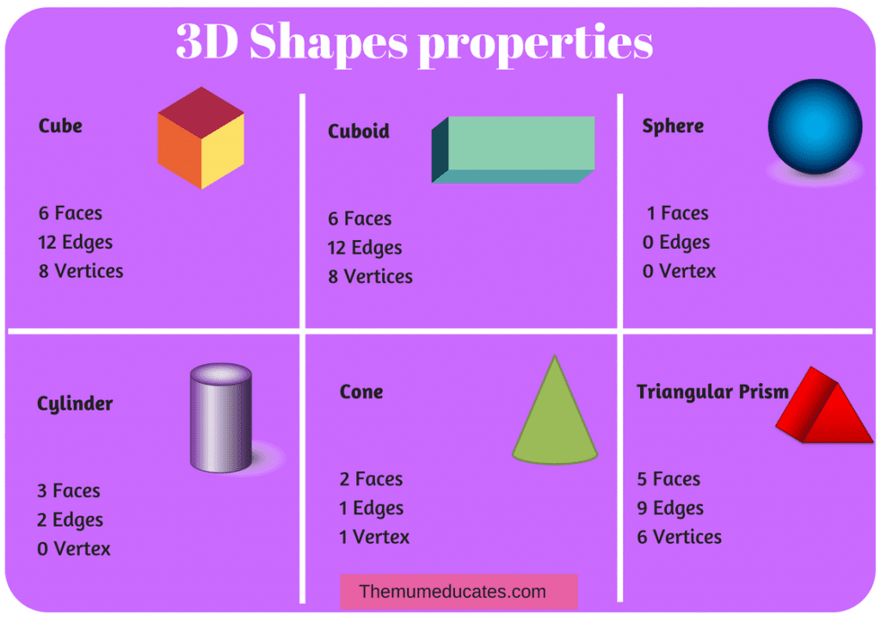
Learn the properties of these 3D Shapes. If you know them well, it is an easy maths question to get marks for.
Some different ideas of materials you could use to make 3D shapes.
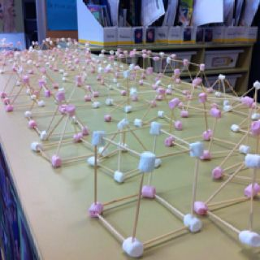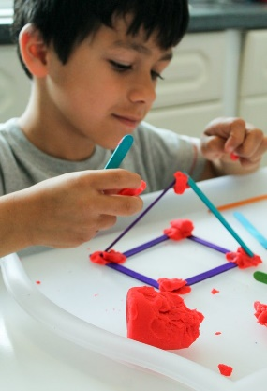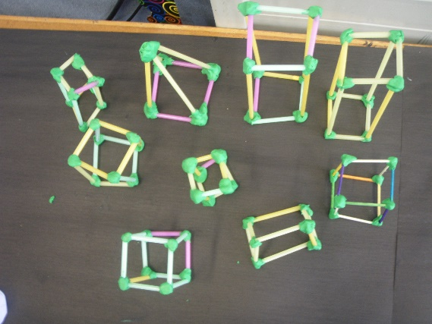

Keep working on division tables and divisions sums. It is about getting used to the method of dividing. You do not have to do all of these, work at the level you feel your child is capable of at this time and you can work your way up.

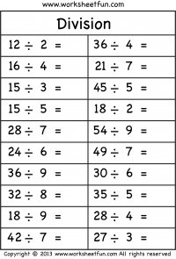

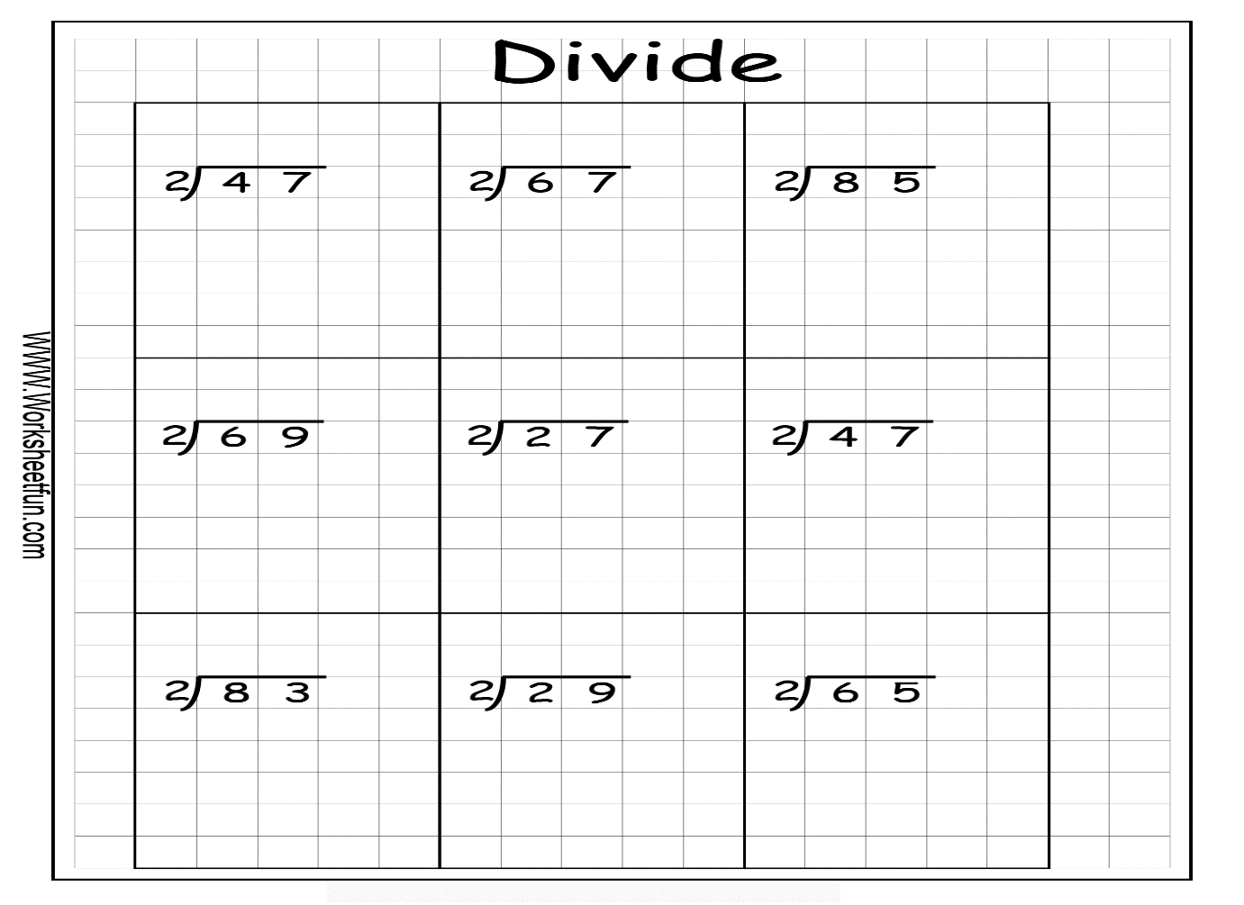

Rewrite these division sums using the box to divide, just as they are written in the page above.
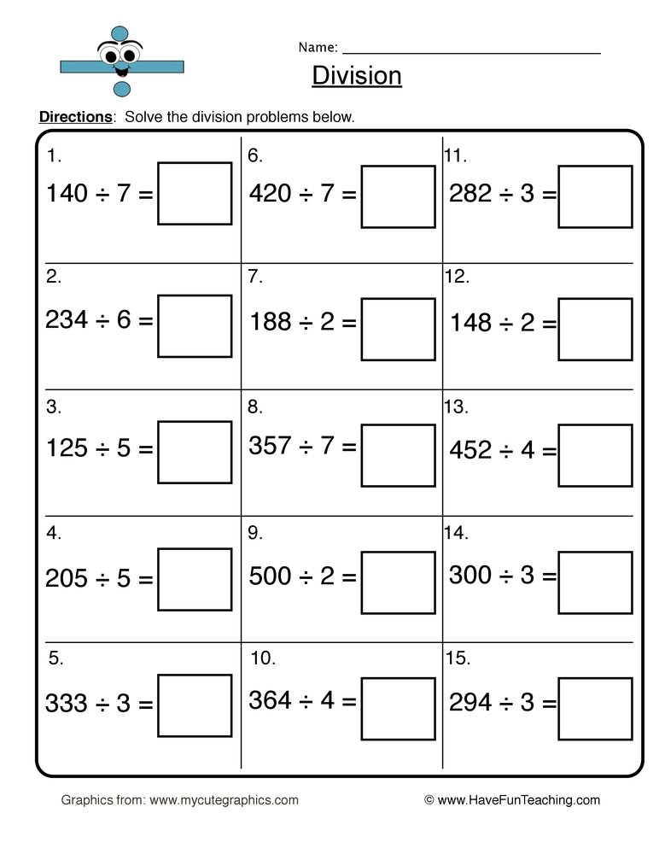

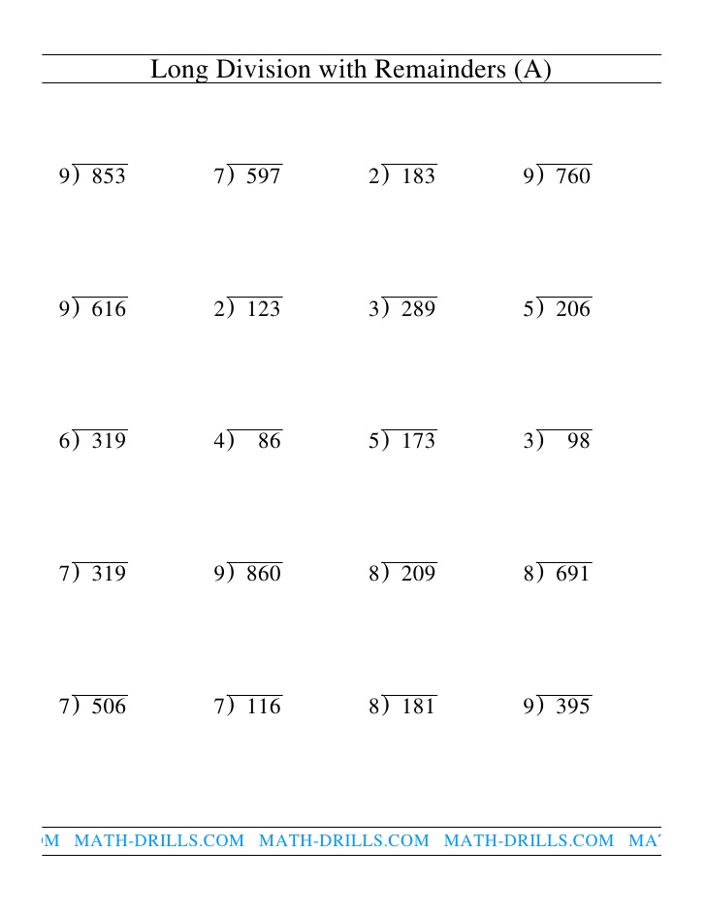

Students can get more work on 3D Shapes in the Planet Maths Book on folensonline (pg 152 3rd class and 167 4th class). Also students can continue to work on mental maths.

Gaeilge
Another postcard this week from an Irish college. Try reading it and if you are on seesaw you could send it to me. Again, learn the postcard for spellings, try as much as you can manage. Some children may like to continue to add in sentences. You can draw an image of the Irish college on the other side of your postcard. Keep this with the previous postcards and continue to look over them all.

Dia duit…….Hello…………..
Tá mé i gcoláiste Gaeilge. I am in Irish college
Tháinig mé sa charr I came in the car
Níl an aimsir go maith The weather isn't good
Tá gach duine an-cháirdiúil Everyone is very friendly
Tá an bia blasta The food is tasty
Slán bye

https://www.bing.com/videos/search?q=eadai&&view=detail&mid=AEEDA1F900694EF75031AEEDA1F900694EF75031&&FORM=VDRVRV
https://www.bing.com/videos/search?q=eadai&&view=detail&mid=576B14EC9BC51455FB58576B14EC9BC51455FB58&&FORM=VDRVRV
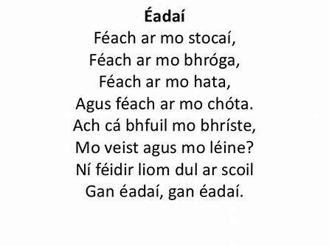

History
Is there anything historical within your 5km area. Maybe you could visit it. Ask your parents about it and draw a picture of it.
If you find something interesting be sure to send us on a picture. I know Raphoe has lots of history.
Find out 5 facts about the pyramids in Egypt.

Georgraphy
Weather
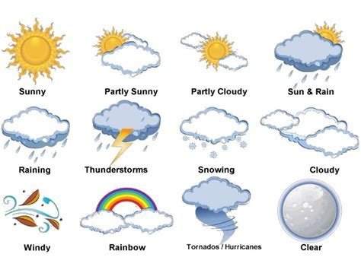
Weather and Climate
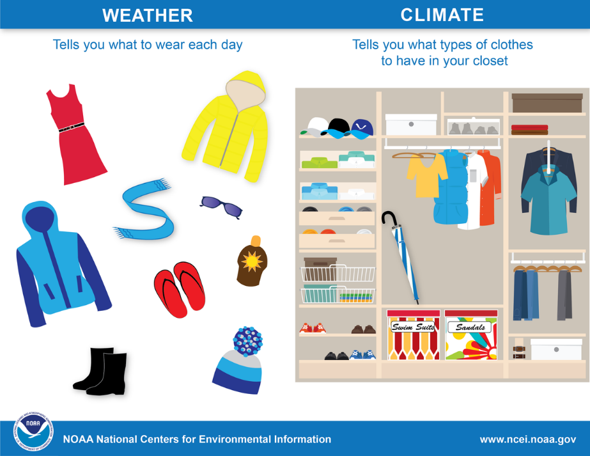

Weather and Climate
https://www.youtube.com/watch?v=vH298zSCQzY
Research some of the weather instruments and you could even try to make some.
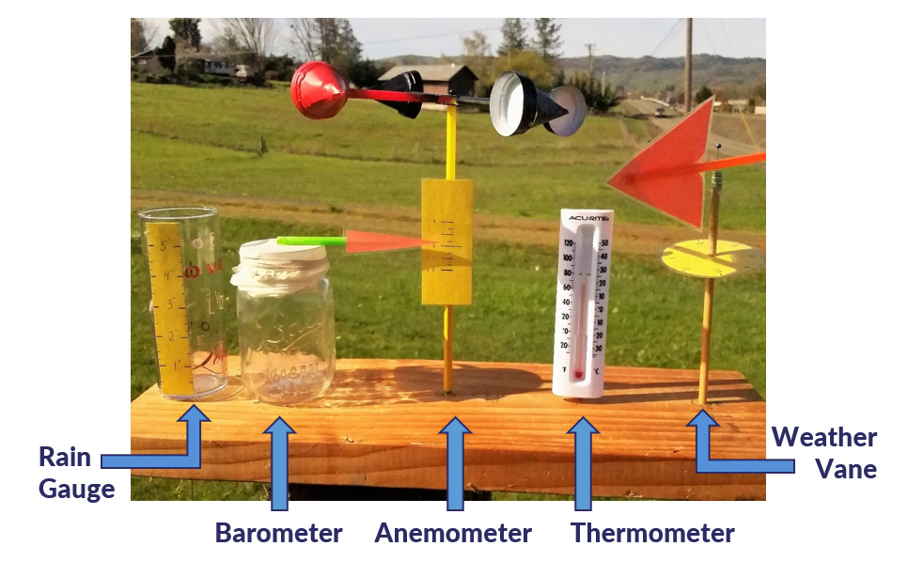

Science
https://www.youtube.com/watch?v=lAy3e-4Uzv8
Weather in a jar

Mini Beast Hunt
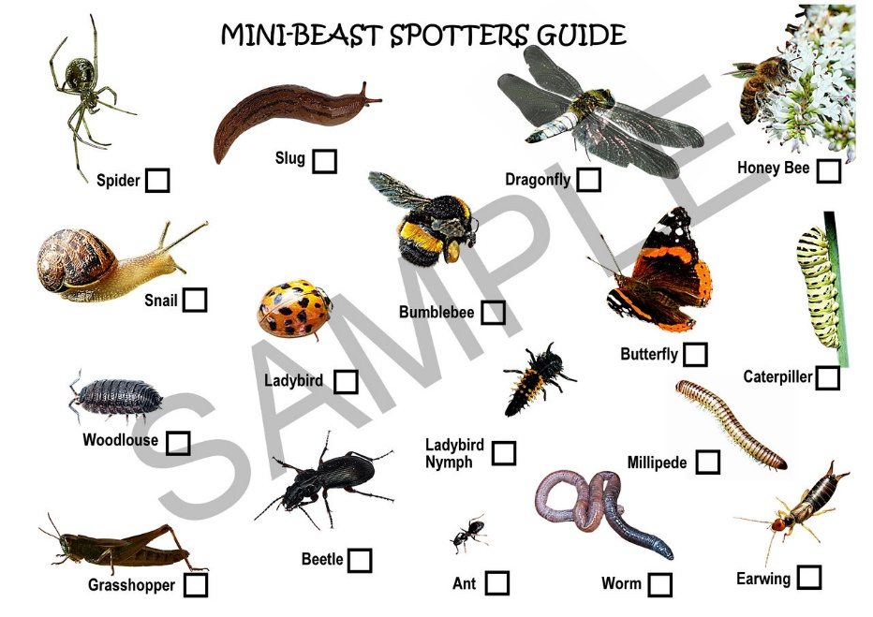
Music
https://www.youtube.com/watch?v=ZrqF7yD10Bo

Art
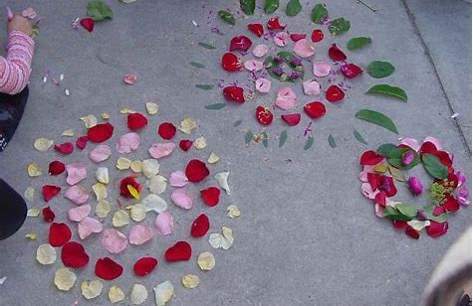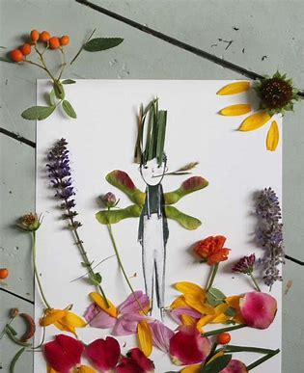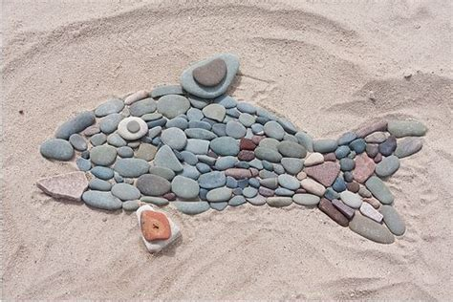

Religion
https://www.youtube.com/watch?v=Fm6ss1PBC1Q

Lady of Knock
There were people of all ages gathered 'round the gable wall
poor and humble men and women, little children that you called
we are gathered here before you, and our hearts are just the same
filled with joy at such a vision, as we praise Your Name
Golden Rose, Queen of Ireland, all my cares and troubles cease
as we kneel with love before you, Lady of Knock, my Queen of Peace
Though your message was unspoken, still the truth in silence lies
as we gaze upon your vision, and the truth I try to find
here I stand with John the teacher, and with Joseph at your side
and I see the Lamb of God, on the Altar glorified
Golden Rose, Queen of Ireland, all my cares and troubles cease
as we kneel with love before you, Lady of Knock, my Queen of Peace
And the Lamb will conquer and the woman clothed in the sun
will shine Her light on everyone
and the lamb will conquer and the woman clothed in the sun,
will shine Her light on everyone

Enjoy the great outdoors this week.

