May 11th
First class – Mrs Gallagher
Hi all,
I hope that you are all well and staying safe. Here is the class work list for this week. Remember this is a guide only and you are free to pick and choose what suits you and your child.

Reading –
I have another book for the children on bugs this week. Copy and paste the address bar below into your Google and it will take you directly to the book.
If this doesn’t work just log into monkey pen.com and look for this book
Do you wonder why bugs are good? https://cdn.shopify.com/s/files/1/2081/8163/files/Do_you_Wonder_Why_Bugs_Are_Good.pdf?5538787067396429544

and
Terrance Turtles New Home
https://cdn.shopify.com/s/files/1/2081/8163/files/Terrance_Turtles_New_Home-Work.pdf?5538787067396429544

Poem on Bees will be on Seesaw with instructions but if you have not logged into seesaw you can always start this week.
Our class code is QUVXTSIT
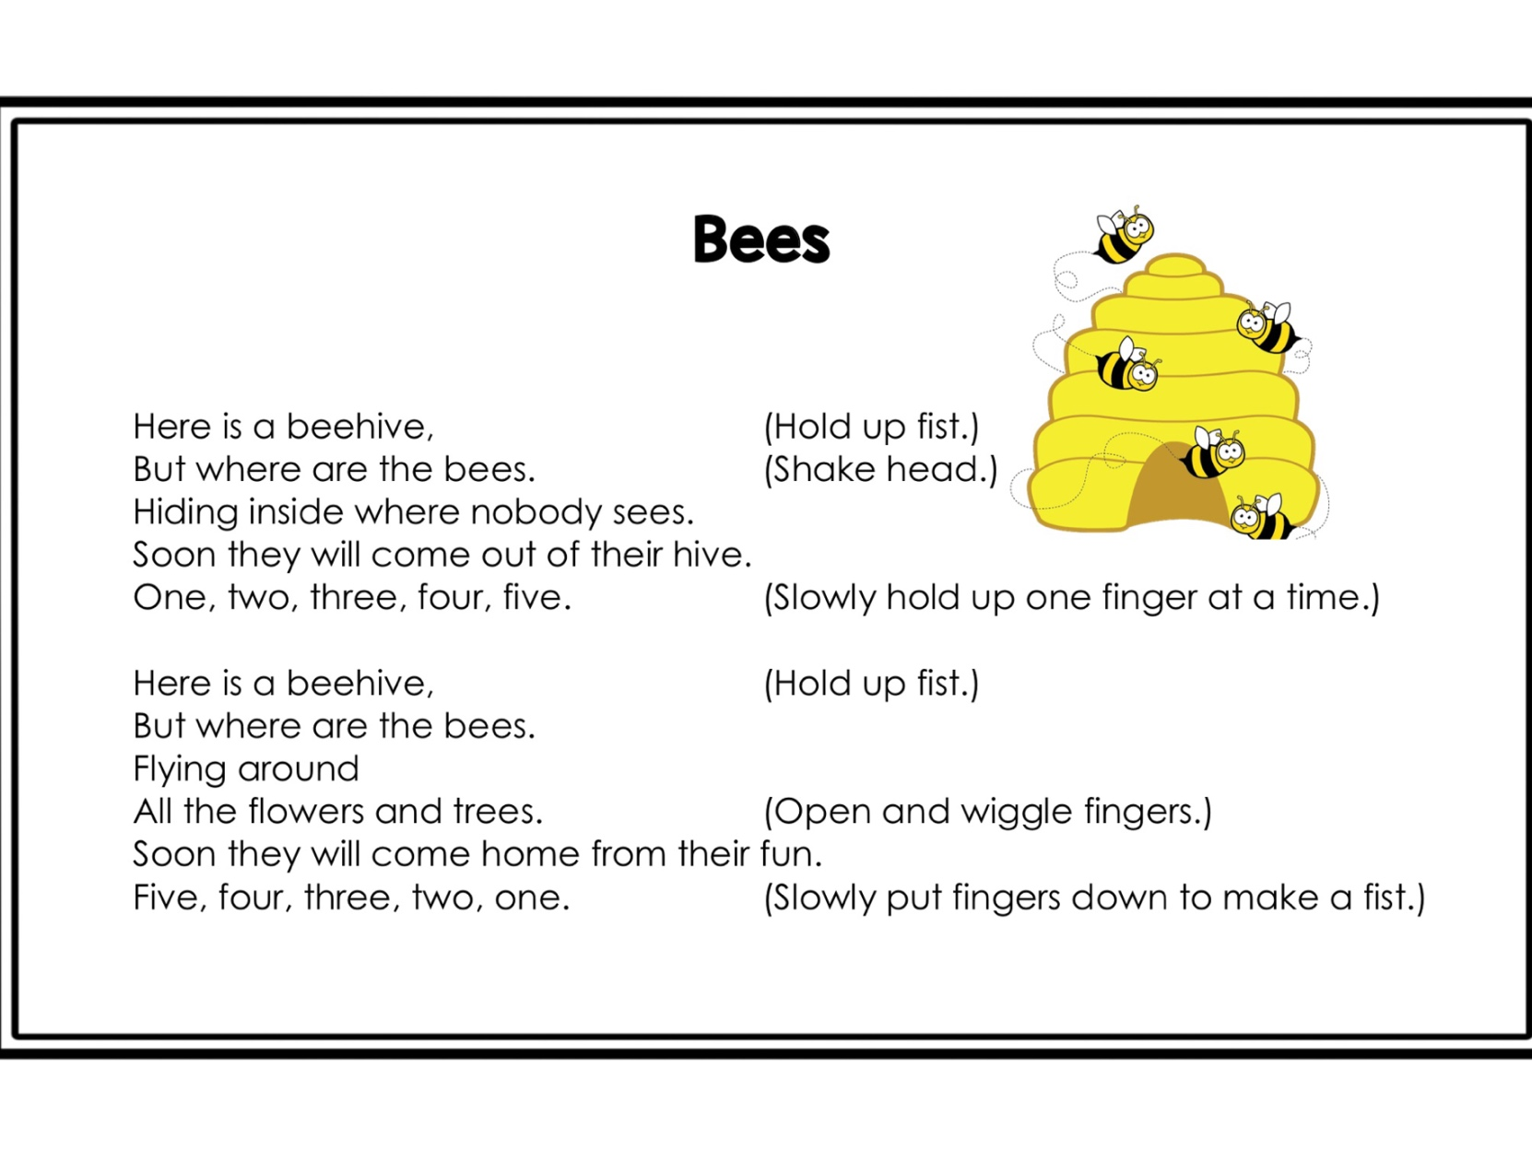 Spellings-
This week’s spellings are i with the magic e (this week I would like you to write your spellings and choose a different colour for the e and the, i. Also, when you know them really well try and write them backwards for Mum or Dad on Friday. You will have to know them really well if you want to do this!
ripe
kite
slime
time
hide
wide
ride
tide
pine
spine

Sentences – This week write each word in a silly sentence.

Irish – This week I would like the children to listen to some Irish stories from ( leighanois.com/display2.php?articleid=56)
https://www.leighanois.com/leabhair.php?banda=1
This is a lovely way for the children to hear the story being read in Irish. Let them listen a few times and then switch off the audio to see how they get on by themselves.
Stay on book band 1 (pink) Seo Mé this week
They could even write a few sentences about themselves and draw a picture to illustrate it.
e.g.
Tá mé ag déanamh obair bhaile.

You might like to try the Folens online Irish books for 1st class. Here is a link for Abair Liom 1st class online
https://www.folensonline.ie/home/library/programmes/abair-liom-1st-class/ebook/
If you can link in, its all about mé féin = myself .Let the children look at the pictures, say the words and listen to the instructions for pages 6,8,9.

Maths – keep giving the children a block of maths daily pg. 66, 67
Planet Maths - pages 121,122,123,124,
This week it’s all about 3D shapes and because we are at home there is lots of opportunity for the children to explore these shapes around the house. Ask them to count the face, edges and corners of their objects.
Remember that a 3 D shape is a solid object with 3 dimensions, height, length and width.

Corner
Edges Face

Some quick fire maths for during the week, maybe set a time for these to be completed.

Monday
8  + 4 | 12  + 9 | 7  + 12 | 12  + 5 | 4  + 12
6  + 12 | 7  + 11 | 11  + 5 | 22  + 4 | 14  + 3
9  + 6 | 5  + 5 | 2  + 17 | 11  + 12 | 7  + 22
1  + 18 | 2  + 24 | 4  +1 3 | 3  +1 5 | 5  + 14

TUESDAY
9  + 3 | 11  + 7 | 7  + 12 | 12  + 8 | 5  + 11
6  + 12 | 8  + 11 | 10  + 4 | 12  + 4 | 8  + 3
6  + 8 | 5  + 6 | 2  + 17 | 1  + 12 | 7  + 12
2  + 18 | 2  + 13 | 4  + 3 | 3  + 5 | 5  + 24

WEDNESDAY
1  + 6 | 5  + 3 | 5  + 12 | 6  + 11 | 13  + 4
2  + 4 | 6  + 5 | 18  + 2 | 14  + 3 | 11  + 3
2  + 11 | 10  + 5 | 4  + 13 | 2  + 14 | 13  + 6
2  + 4 | 10  + 2 | 5  + 2 | 14  + 3 | 10  + 10

THURSDAY
2  + 6 | 12  + 4 | 11  + 8 | 9  + 7 | 11  + 2
3  + 7 | 5  + 9 | 7  + 3 | 3  + 7 | 15  + 1
4  + 1 | 9  + 1 | 2  + 12 | 6  + 12 | 4  + 11
10  + 7 | 6  + 11 | 4  + 3 | 9  + 4 | 2  + 16

FRIDAY
13  + 5 | 17  + 5 | 12  + 10 | 11  + 12 | 14  + 3
7  + 3 | 3  + 7 | 14  + 3 | 17  + 3 | 13  + 4
4  + 10 | 9  + 10 | 4  + 5 | 5  + 5 | 6  + 13
7  + 13 | 7  + 3 | 2  + 13 | 10  + 3 | 8  + 3
Language
Word Wise 1 – Unit 18
page 57 Springtime pages 70,71,72,73

Exercise Your English
page 76 Magic e words

SESE – Science, history and geography

Learning all about Neil Armstrong page 53 Explore with me
https://www.edcolearning.ie/Book/Page?bookId=book853&chapterId=chapter11&pageId=page56
or search Google to find out all about Neil Armstrong
Try making a rocket on page 54
Below is a wee template to copy or build your own.
This week is all about construction so you could build a rocket from all your 3 d shaped litter that you are gathering or with your lego.
When it is finished, take a picture for the Facebook page showing your construction.

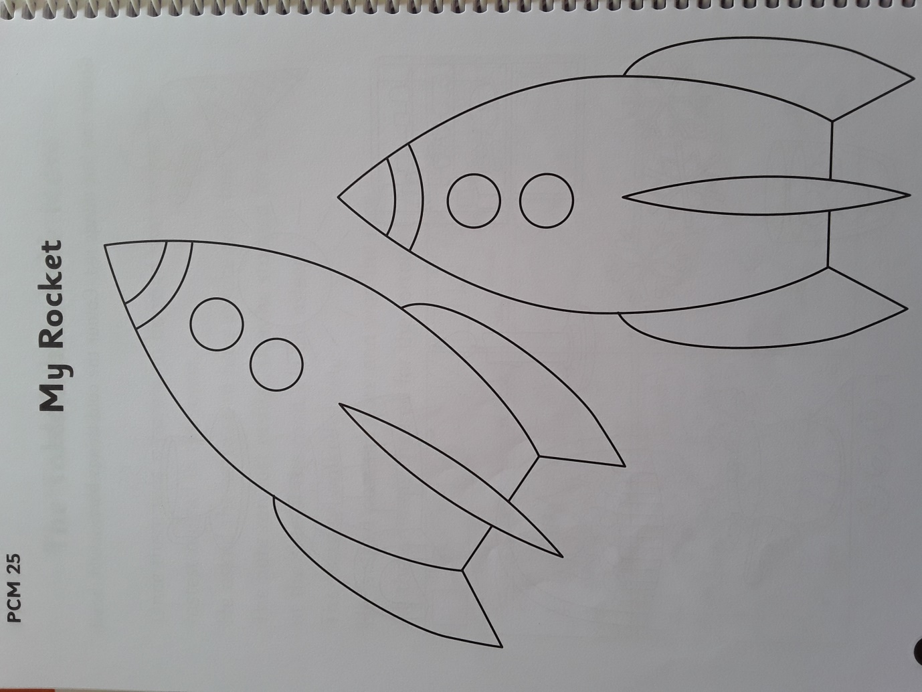

Our class e mail address is firstclass.steunans@gmail.com
Please do not hesitate in contacting me if you have any queries. Good luck with all the work, pick what you want and God bless.
Don’t forget to log into your seesaw account and take part in the activities during the week.
Kind regards
Mrs Gallagher

Mrs McCaffrey has sent an e mail containing all her work to all her pupils.
Do not hesitate to contact her on her e mail if you have any queries.
Many thanks,
Mrs McCaffrey

