May 5th
First class – Mrs Gallagher
Hi all,
I hope that you are all well and staying safe. The children are never far from my thoughts. Here is your work for this week. As it’s only a 4 day week you can pick and choose what work to complete. Remember this is only a guide, you can complete as much as you need, remember every child is different.

Reading –
This week we can try a new reading site and I have a link for this lovely book which is appropriate for the children and the parents at the moment yuck!
https://cdn.shopify.com/s/files/1/2081/8163/files/Homework_-_Yuck.pdf?5538787067396429544
If this doesn’t work just log into monkey pen.com and look for this book
You can read another if you find this too easy!

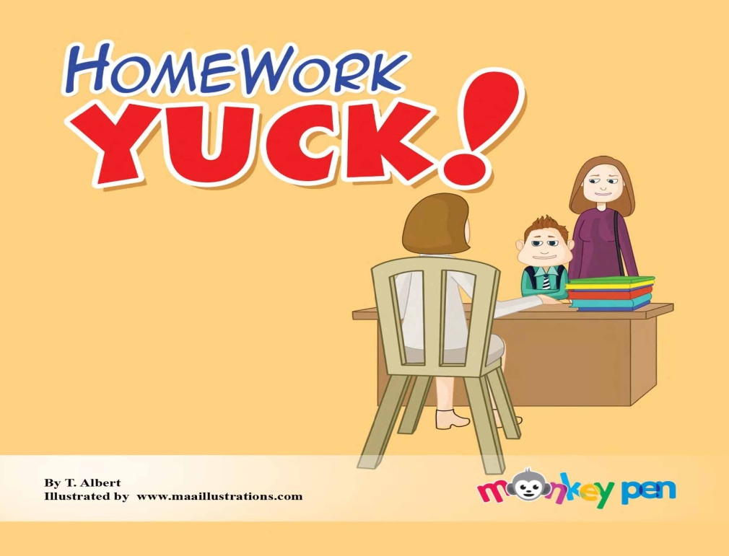

Spellings-
Only 4 days of spellings this week.
On Friday they can practice writing them down using their opposite hand. (Just for a change and for the crack)
‘aw’words
was
all
off
saw
ball
want
talk
draw
wall
fall
small
paw
doll
walk
Why not try and spell the word, write it or 2 in a sentence. Draw a picture to represent the sentence.
Write your spellings in bubble writing or fancy writing! Script or Bold, all different colours, take pictures I’d love to see them

SESE- This fortnight we are looking at space.
Look and discuss unit 8 Explore with me, little book of posters and answer the questions to stimulate discussion on space.
Find any you tube video for kids relating to Aesops Fables - The wind and the sun
or follow this link
https://www.youtube.com/watch?v=0GGvRtuxglM
Complete the workbook page 50 Explore with me
You can also click on this link and it will take you directly to the online resource from Edco
https://edcolearning.ie/Book/Page?bookId=book853&chapterId=chapter11&pageId=page54
Planet Earth in Space pg 52 discuss the sun and the moon
Feel free to research about the sun and moon on your kiddle or Google

Science- pg 51 - Discuss whether a tea cosy will keep water warmer for longer. Why not investigate by using a hat instead of a tea cosy, they’re not so popular these days. Phone Granny or Granda and ask them if they know why a tea cosy is used?
What keeps the body warm?, discuss.

Irish – Why not try and learn the Hail Mary in Irish.
This is for the grown-ups also. Who will be the best in your house? I’m sure the children will help you out! The pressure is on!
Here is a link to the podcast to help with pronunciation
http://www.easyirish.com/podcastmedia/eiL17.mp3
or go to Easyirish.com lesson 17

Religion- May is here and we pray to our lady during this beautiful month.
Why not say a Hail Mary every night during this month and pray for each other during this difficult time. Write out the Hail Mary in beautiful writing and colour the picture. don’t forget your May altar!!!

Maths – keep giving the children a block of maths daily pg. 64,65
Planet Maths
–subtraction page 120
Addition 4 page 119
Write out your +2 tables starting with 0+2 up to 12+2
Here is some mental maths that the children can do. Let them write down the sums or the answers. Make it fun by timing them. You can also call out the sums instead of writing them down
TUESDAY
8  + 3 | 12  + 7 | 7  + 11 | 12  + 7 | 4  + 11
6  + 12 | 8  + 11 | 10  + 5 | 12  + 4 | 4  + 3
6  + 6 | 5  + 5 | 2  + 17 | 1  + 12 | 7  + 12
2  + 18 | 2  + 14 | 4  + 3 | 3  + 5 | 5  + 14

WEDNESDAY
1  + 5 | 5  + 5 | 5  + 14 | 6  + 12 | 13  + 5
2  + 2 | 6  + 6 | 18  + 1 | 14  + 5 | 11  + 4
2  + 10 | 10  + 4 | 4  + 14 | 2  + 15 | 3  + 6
2  + 3 | 10  + 1 | 5  + 4 | 18  + 2 | 10  + 10

THURSDAY
2  + 7 | 12  + 7 | 11  + 5 | 9  + 6 | 11  + 3
3  + 7 | 5  + 9 | 7  + 3 | 3  + 7 | 15  + 2
4  + 14 | 9  + 2 | 4  + 12 | 6  + 13 | 4  + 10
10  + 8 | 6  + 10 | 4  + 4 | 9  + 5 | 2  + 17

FRIDAY
14  + 5 | 7  + 5 | 2  + 10 | 1  + 12 | 4  + 3
7  + 3 | 3  + 7 | 13  + 3 | 17  + 3 | 13  + 4
3  + 10 | 8  + 10 | 4  + 5 | 5  + 5 | 6  + 13
7  + 13 | 7  + 3 | 2  + 16 | 10  + 3 | 8  + 6

Language
Word Wise 1 – pg 52 (initial sounds) and 53 grammar

Exercise Your English - Pg 65( final sounds ck,ss)
The story of The Dragonfly pages 71,72,
If you are finished early, look up a few interesting facts about the dragonfly and draw a picture of it.
Vowels ( a,e,i,o,u.)
Revise your vowel song to the tune of’ Bingo’
To make a word you always need a vowel for the glue,
a, e, i, o, u , a, e, i, o, u , a, e, i, o, u,
the vowels are the glue

Our class e mail address is firstclass.steunans@gmail.com
Please do not hesitate in contacting me if you have any queries. Good luck with all the work and God bless.
Don’t forget to log into your seesaw account and take part in the activities during the week.

Good luck with all the work and God bless.
Kind regards
Mrs Gallagher

Mrs McCaffrey has sent an e mail containing all her work to all her pupils.
Do not hesitate to contact her on her e mail if you have any queries.
Many thanks,
Mrs McCaffrey

