May 5th
Senior Infants – Mrs Gallagher
Hi all,
I hope that you are all well and staying safe. The children are never far from my thoughts. Here is your work for this week. As it’s only a 4 day week you can pick and choose what work to complete. Remember this is only a guide, you can complete as much as you need, remember every child is different.

Reading –
This week we can try a new reading site and I have a link for this lovely book which is appropriate for the children and the parents at the moment yuck!
https://cdn.shopify.com/s/files/1/2081/8163/files/Homework_-_Yuck.pdf?5538787067396429544

If this doesn’t work just log into monkey pen.com and look for this book

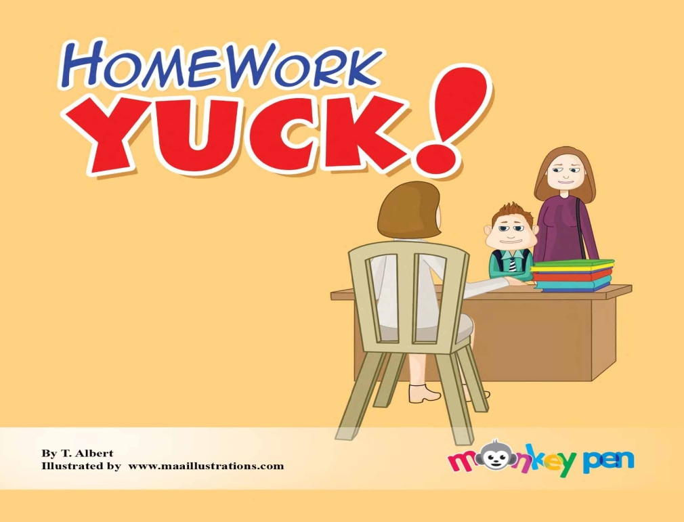

Spellings- ing words
Only 4 days spellings this week.
On Friday they can practice writing them down using their opposite hand. (Just for a change)
‘ing’ words
King
ring
ding
wing
swing
sing
sting
bring
Why not try and spell the word, write it in a sentence. Draw a picture to represent the sentence.
Write your spellings in bubble writing or fancy writing! Script or Bold, all different colours

SESE- This fortnight we are looking at space.
Look and discuss unit 8 Explore with me, little book of posters and answer the questions to stimulate discussion on space.
Find any you tube video for kids relating to Aesops Fables - The wind and the sun
or follow this link
https://www.youtube.com/watch?v=0GGvRtuxglM
Complete the workbook page 50 Explore with me
You can also click on this link and it will take you directly to the online resource from Edco
https://edcolearning.ie/Book/Page?bookId=book853&chapterId=chapter11&pageId=page54
Planet Earth in Space pg 52 discuss the sun and the moon
Feel free to research about the sun and moon on your kiddle or Google

Science- pg 51 Discuss whether a tea cosy will keep water warmer for longer. Why not investigate by using a hat instead of a tea cosy, they’re not so popular these days.
What keeps the body warm, discuss.

Irish – Why not try and learn the Hail Mary in Irish.
This is for the grown-ups also. Who will be the best in your house? I’m sure the children will help you out! The pressure is on!
Here is a link to the podcast to help with pronunciation
http://www.easyirish.com/podcastmedia/eiL17.mp3
or go to Easyirish.com lesson 17

Religion - May is here and we pray to our lady during this beautiful month.
Why not say a Hail Mary every night during this month and pray for each other during this difficult time. Write out the Hail Mary in beautiful writing, fill in the gaps and colour the picture.

Maths – keep giving the children a block of maths daily pg. 64,65
Here are some mental maths that the children can do. Let them write down the sums or the answers. Make it fun by timing them. You can also call out the sums instead of writing them down.

TUESDAY
3 + 4 = | 3 + 6 = | 2 + 7 = | 4 + 7 = | 2 + 2 =
1 + 7 = | 3 + 5 = | 4 + 8 = | 3 + 8 = | 3 + 2 =
2 + 3 = | 2 + 4 = | 3 + 7 = | 1 + 8 = | 4 + 9 =
1 + 4 = | 2 + 2 = | 3 + 9 = | 3 + 5 = | 2 + 2 =

WEDNESDAY
3 + 8 = | 1 + 3 = | 3 + 8 = | 4 + 7 = | 2 + 5 =
3 + 10 = | 2 + 5 = | 2 + 7 = | 2 + 3 = | 2 + 9 =
3 + 3 = | 2 + 7 = | 1 + 6 = | 3 + 7 = | 1 + 2 =
2 + 9 = | 2 + 7 = | 2 + 3 = | 2 + 3 = | 1 + 6 =

THURSDAY

4 + 8 = | 2 + 3 = | 1 + 2 = | 2 + 4 = | 3 + 7 =
4 + 8 = | 1 + 4 = | 2 + 2 = | 4 + 6 = | 4 + 6 =
2 + 8 = | 1 + 6 = | 3 + 4 = | 2 + 5 = | 2 + 6 =
3 + 5 = | 3 + 6 = | 3 + 9 = | 2 + 4 = | 3 + 7 =

FRIDAY
1 + 8 = | 2 + 8 = | 3 + 2 = | 2 + 7 = | 3 + 4 =
2 + 5 = | 2 + 6 = | 3 + 1 = | 2 + 10 = | 3 + 8 =
1 + 4 = | 3 + 5 = | 1 + 6 = | 3 + 4 = | 3 + 4 =
3 + 4 = | 2 + 3 = | 2 + 3 = | 4 + 2 = | 2 + 8 =

Language
Word Wise –pg 79 oral language discuss the picture and answer the questions
Phonics practice the( ing) words pages 51,52 Don’t be afraid to add to these with more of your own.

Exercise Your English - Oral language –pg 64 Let’s talk
Pg 65, vowels a,o,u
Revise your vowel song to the tune of’ Bingo’
To make a word you always need a vowel for the glue,
a, e, i, o, u , a, e, i, o, u , a, e, i, o, u,
the vowels are the glue

Our class e mail address is firstclass.steunans@gmail.com
Please do not hesitate in contacting me if you have any queries. Good luck with all the work and God bless.

Don’t forget to log into your seesaw account and take part in the activities this week.
Good luck with all the work and God bless.
Kind regards
Mrs Gallagher

Mrs McCaffrey has sent an e mail containing all her work to all her pupils.
Do not hesitate to contact her on her e mail if you have any queries.
Many thanks,
Mrs McCaffrey

