May 11th
Senior Infants – Mrs Gallagher
Hi all,
I hope that you are all well and staying safe. Here is the class work list for this week. Remember this is a guide only and you are free to pick and choose what suits you and your child.

Reading –
I have another book for the children on bugs this week
If this doesn’t work just log into monkey pen.com and look for this book
Do you wonder why bugs are good? https://cdn.shopify.com/s/files/1/2081/8163/files/Do_you_Wonder_Why_Bugs_Are_Good.pdf?5538787067396429544
and if you think they are able for another one try
Gabby Abby
https://cdn.shopify.com/s/files/1/2081/8163/files/Gabby_Abby.pdf?5538787067396429544

Language
Word Wise 1 – odd one out page 68
Oral language pg 70 (if this is already done go on to page 72)

Exercise Your English -
page 66,67 mixed up sentences

SESE – Science, history and geography
Learning all about Neil Armstrong page 53 Explore with me
https://www.edcolearning.ie/Book/Page?bookId=book853&chapterId=chapter11&pageId=page56
or search Google to find out all about Neil Armstrong
Try making a rocket on page 54
Here is a wee template to copy or come up with a design of your own using recycled items from your rubbish.
This week is all about construction. Can you make a rocket from your toys?
bricks, stones, lego, jenga blocks? The more imaginative the better.
Take a photo of your rocket for FB or seesaw.
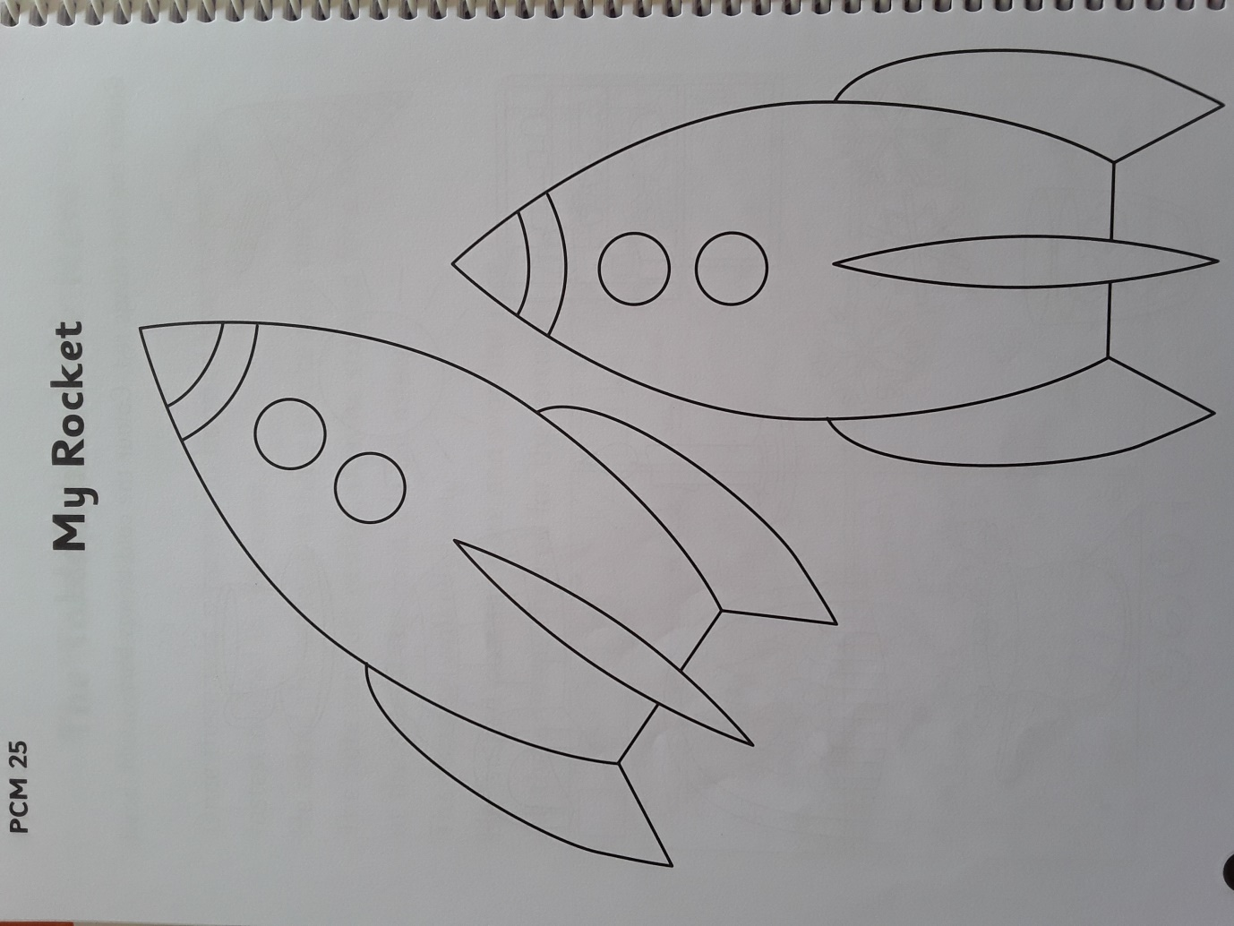

Poem on Bees will be on Seesaw with instructions but if you have not logged into seesaw you can always start this week. Our class code is QUVXTSIT
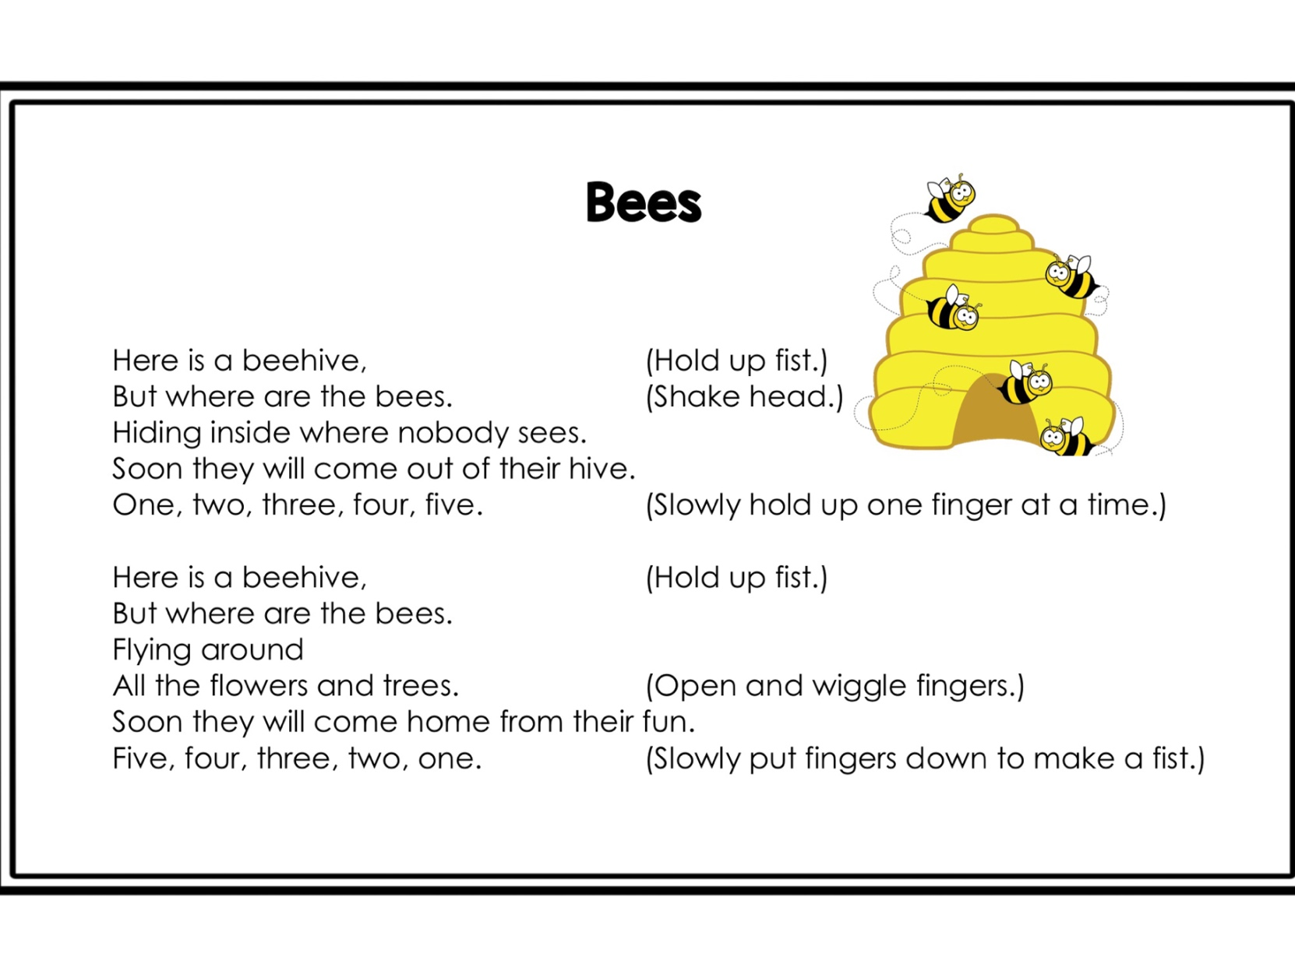 Spellings-
This week’s spellings the “ee” sound.
This week I would like you to write your spellings and choose a different colour for the ee part of the word. Also, when you know them really well try and write them backwards for Mum or Dad on Friday. Keep practicing on your little boards.
You will have to know them really well if you want to do this!
bee
keep
seed
need
weed
deep
free
three
creep
sheep

Sentences – This week write each word in a silly sentence and draw a picture if you have time.

Another fable this week is the Hair and the tortoise. You could watch it on YouTube first, and then the children can read this piece and say which number goes into the boxes. .https://www.youtube.com/watch?v=pjokVI0LJzw
All oral language you can discuss the moral of the story. This is a lovely story when discussing kindness and how we all have different talents.

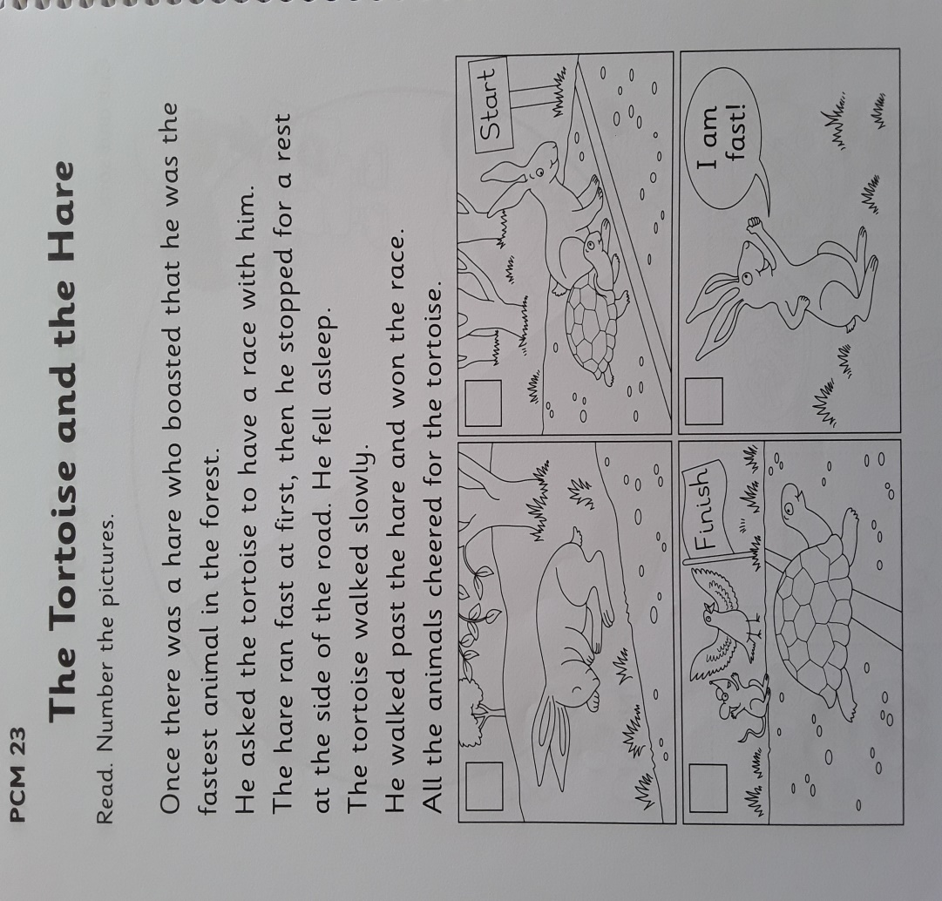

Irish – This week I would like the children to listen to some Irish stories from ( leighanois.com/display2.php?articleid=56)
https://www.leighanois.com/leabhair.php?banda=1
This is a lovely way for the children to hear the story being read in Irish. Let them listen a few times and then switch off the audio to see how they get on by themselves.
Stay on book band 1 (pink) Seo Mé this week
They could even write a few sentences about themselves and draw a picture to illustrate it. (Just a suggestion.)
e.g.
Tá mé ag déanamh obair bhaile. I am doing homework

Maths – keep giving the children a block of maths daily pg. 66, 67
Some quick fire maths for the children
MONDAY
8 - 4 = | 6 - 4 = | 7 - 1 = | 9 - 5 = | 8 - 8 =
3 - 2 = | 8 - 3 = | 10 - 8 = | 9 - 3 = | 9 - 6 =
9 - 5 = | 6 - 5 = | 3 - 3 = | 5 - 2 = | 7 - 4 =
10 - 3 = | 5 - 4 = | 6 - 3 = | 8 - 4 = | 7 - 2 =

TUESDAY
8 - 6 = | 9 - 7 = | 7 - 3 = | 9 - 3 = | 2 - 1 =
8 - 7 = | 10 - 9 = | 9 - 2 = | 4 - 2 = | 6 - 5 =
4 - 2 = | 3 - 1 = | 9 - 6 = | 3 - 3 = | 3 - 2 =
6 - 3 = | 7 - 3 = | 8 - 5 = | 9 - 4 = | 5 - 2 =

WEDNESDAY

9 - 2 = | 8 - 5 = | 9 - 6 = | 7 - 1 = | 10 - 4 =
6 - 5 = | 7 - 2 = | 6 - 2 = | 8 - 2 = | 5 - 4 =
5 - 3 = | 8 - 3 = | 3 - 2 = | 7 - 6 = | 9 - 3 =
3 - 2 = | 9 - 5 = | 2 - 2 = | 6 - 3 = | 8 - 1 =

THURSDAY

9 - 3 = | 4 - 3 = | 5 - 4 = | 9 - 5 = | 10 - 8 =
7 - 1 = | 6 - 1 = | 9 - 1 = | 6 - 3 = | 10 - 5 =
8 - 3 = | 6 - 5 = | 6 - 3 = | 10 - 10 = | 9 - 2 =
9 - 3 = | 9 - 6 = | 9 - 7 = | 2 - 2 = | 3 - 1 =

FRIDAY

7 - 1 = | 3 - 1 = | 10 - 1 = | 10 - 9 = | 6 - 2 =
8 - 1 = | 8 - 5 = | 7 - 7 = | 4 - 3 = | 3 - 2 =
9 - 4 = | 9 - 5 = | 7 - 5 = | 7 - 3 = | 5 - 1 =
7 - 6 = | 6 - 1 = | 6 - 5 = | 8 - 3 = | 9 - 2 =

We are doing capacity this week so it’s a perfect time to let the children explore with water and containers outside of course!

Let them use various containers to experiment, cup, eggcup, jam jar, saucepan, empty milk carton, bowl, plastic bottle or bottle tops.
Encourage this language full, empty, holds more, holds less, holds the same amount, pour, fill, up to the top, enough, level. They can copy out these work pages into their copy books or just tell you the answers.
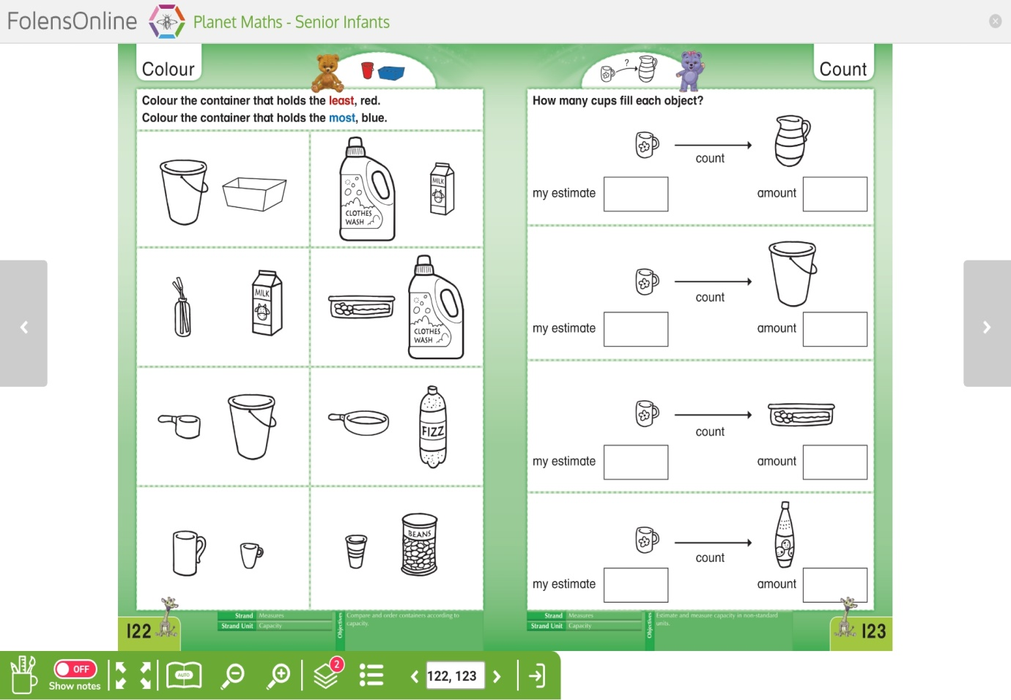

I will be putting this activity up next week so the children can fill it out there also.

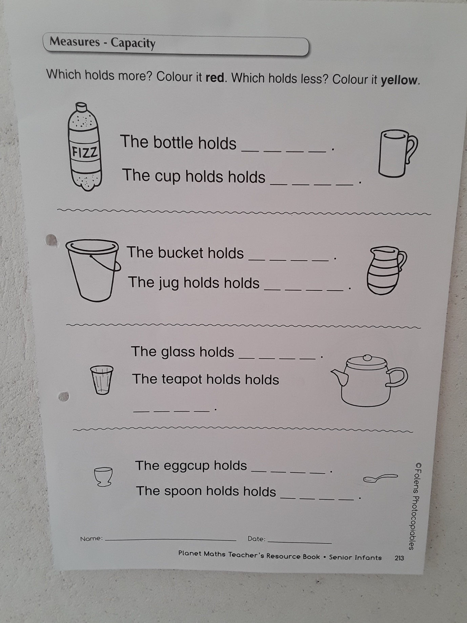

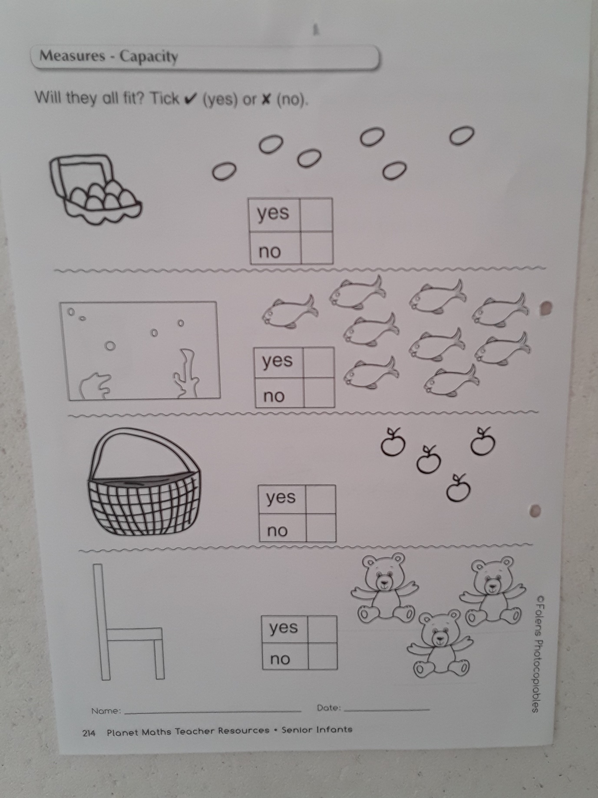
The children can answer these questions orally, no need to write them down unless they want to.

Our class e mail address is firstclass.steunans@gmail.com
Please do not hesitate in contacting me if you have any queries. Good luck with all the work, pick what you want and God bless.
Don’t forget to log into your seesaw account and take part in the activities during the week.
Kind regards
Mrs Gallagher

Mrs McCaffrey has sent an e mail containing all her work to all her pupils.
Do not hesitate to contact her on her e mail if you have any queries.
Many thanks,
Mrs McCaffrey

