Mrs Keeve’s Worklist- 5th May.
I hope everyone enjoyed Active Week. It is the start of summer and it is ideal to continue all these active activities. Last week was also Poetry Day Ireland 2020. We have wonderful writers in our class. Remember boys and girls you can always continue Free Writing no matter where you are. Keep up the great work boys and girl. Missing you all!
Use this poem to create your own version
https://www.youtube.com/watch?v=llugzgPjWWU
Seagull
Seagull,Seagull,
Riding high,
What do you see,
With your bold bright eye?

I see……………………………………………………….
On/In/By a…………………………………………………..

I hear ………………………………………………………….
On/In/By a……………………………………………………….

I see………………………………………………………………….
On/In/By……………………………………………………………

I hear………………………………………………………………….
On/In/By…………………………………………………………….

I see the town
And the church and its steeple,
And the Pavements full
Of Hurrying People.
By…………………………………(Write your Name)

Or create your own isolation poem

Summer Spellings
Beach, translucent, transparent, opaque, sandcastle, picnic, shovel, sunglasses, sunscreen, grasshopper, daisy, parasol, swimsuit, paddling, barbecue, vacation, camera, temperature, strawberries.
Any words the children are unsure of, look them up.
Reading
Oxford Owl
Library Books
Why not google some poetry. There is lots on the internet.

Maths
Tables, Tables, Tables
Teach your parents how to play the counting can game. You will need a tin can or baking try. When you drop something like pasta in, it will make a noise. The children close their eyes. For every sound/drop they hear they count up in their multiples. Make it a bit of fun and include other members of the family.
Use your new hundred square to circle the multiples up to 100. You can practise this for all multiples.
Multiplication – If your child is in 3rd class and has mastered short multiplication very well and flies through the sums, I would introduce them to long multiplication. Long multiplication is 4th class work and will be covered next year but I would often introduce it to children who know their tables really, really, really, really well and are flying with short multiplication.
3rd Class
324 x6 , 287 x 5 , 347 x 9 , 459 x 2 , 653 x 7 , 298 x 6 , 871 x 4
4th Class
234 x 34 , 754 x 27 , 367 x 39 , 265 x 45 , 657 x 45 925 x 37

Area
To calculate area, you multiply length by width. When you have an irregular shape, you have to break them into squares or rectangles as you see below. You then calculate the area of each square or rectangle and add them together to get the total area of the irregular shape.
Remember your answer for area will always be cm^{2.}
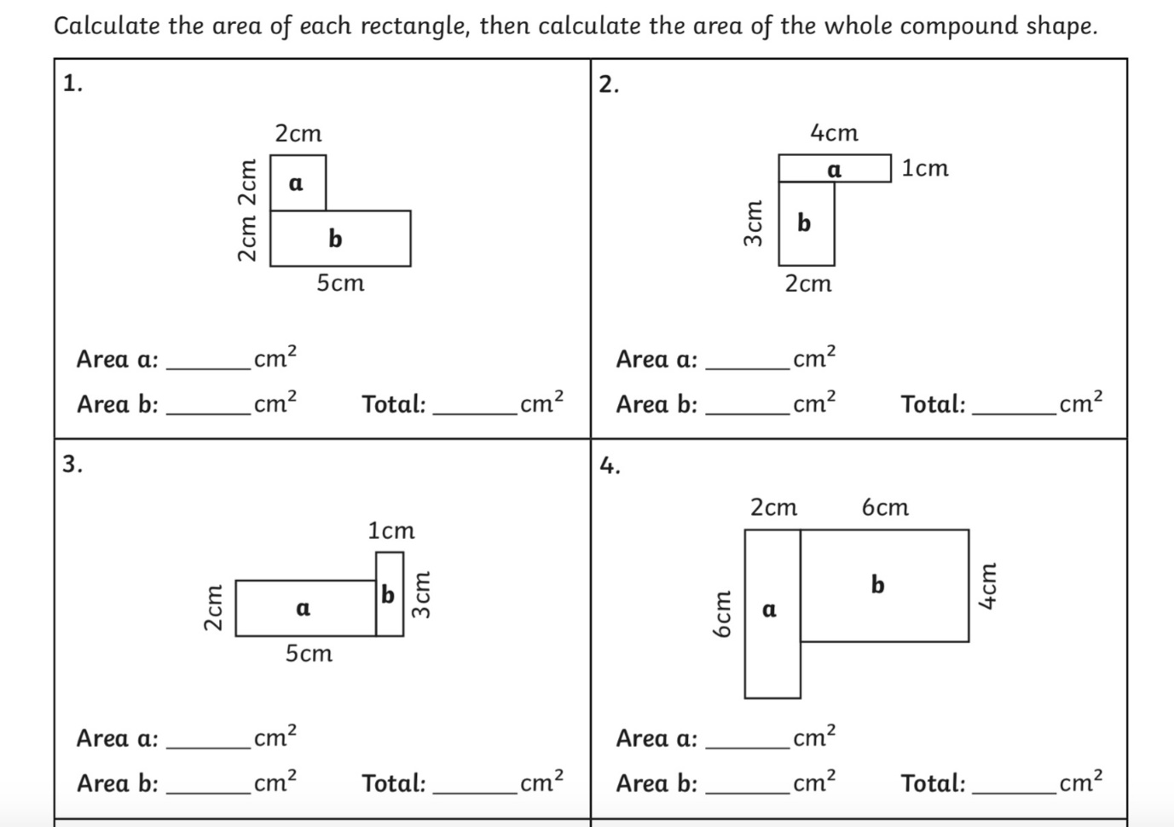
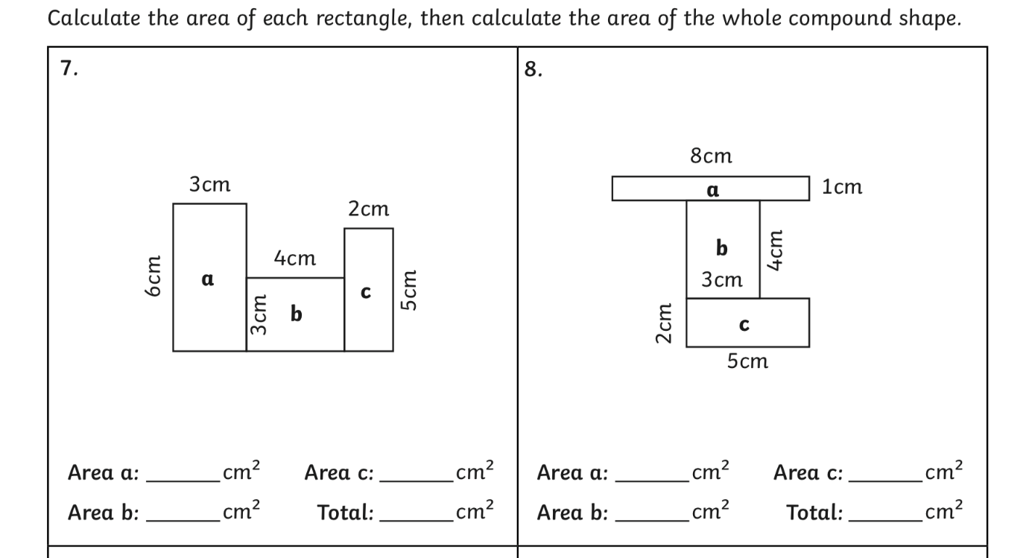
You can then calculate the perimeter of the irregular shapes.
Perimeter = Add all the sides together
If you need more work on area you can do the chapter on area from the Planet Maths Book. See www.folensonline.ie. Page 138 for 3rd and 4th Class Planet Maths.
Also work on Master Your Maths Mental Maths

Gaeilge- Spellings
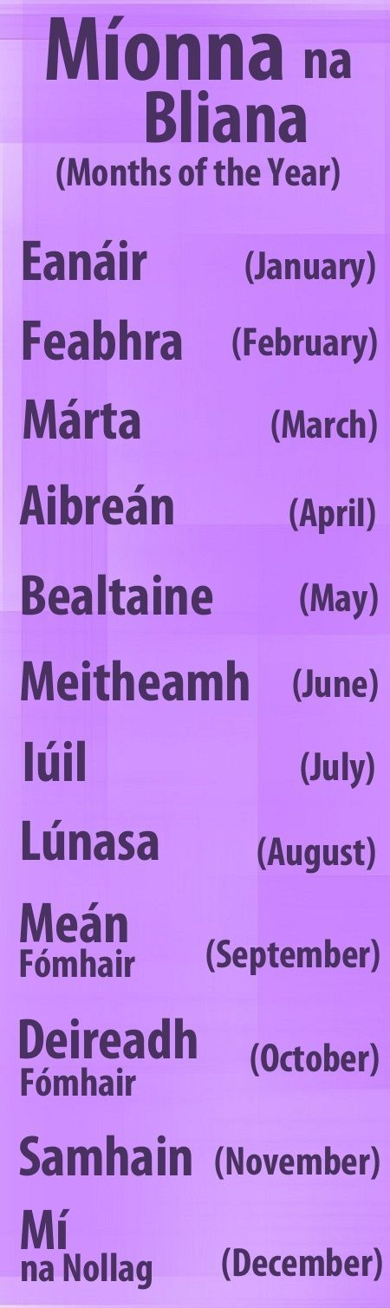

If anyone would like to do the weather forecast from your copies let me know and I will arrange for you to record it on a particular day and we can put it on Facebook. All you need to do is stand by a window or outside. Everyone will learn from you. Just email me or let me know on Seesaw.
Reading
https://www.youtube.com/watch?v=Sn1mxujspEA&list=PLbcLsUBW9b3AsknOKbR0-K_No4maqeKBB

If you feel comfortable with Irish you can continue with Bua na Cainte but I don’t want to put undue stress on parents and children, so we will keep it simple and focus on really important work.

Science -Translucent, Transparent, Opaque

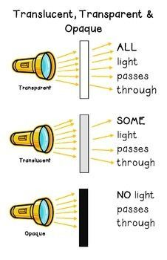Take a torch or hold things up to the light and find things around the house that are transparent, translucent and opaque.
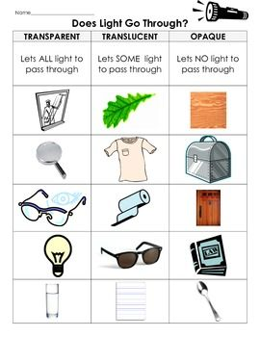

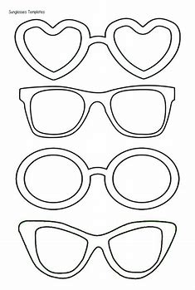

Try different materials for the lenses.

History
The summer solstice is the longest day of the year, and the shortest night. In the Northern Hemisphere it takes place between June 20 and 22, depending on the year. (The reverse is true in the Southern Hemisphere, where the longest day of the year occurs between December 20 and 22.) Humans may have observed the summer solstice as early as the Stone Age. Cultures around the world still celebrate the day with feasts, bonfires, picnics and songs.
https://www.history.com/topics/natural-disasters-and-environment/history-of-summer-solstice
https://www.youtube.com/watch?v=SVzkVsWQBR8
https://www.youtube.com/watch?v=eQV3BAuVnMY
I wonder if the boys and girls can see any links with the Celts and the summer solstice to Beltany Stone Circle.
If it is within your 2km, why not visit Beltany to investigate or you could just google the pictures of it.
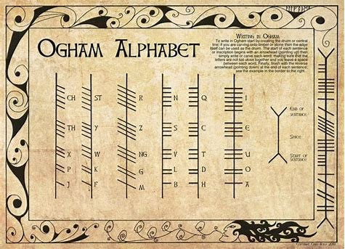
The Boys and Girls could write their names using ogham.
If you have time you could make a model of Beltany Stone Circle

Geography
Draw a map of Raphoe and locate Beltany Stone Circle on the Map.

Art
Create a Summer Garden using an old lid or tray
Just an example.
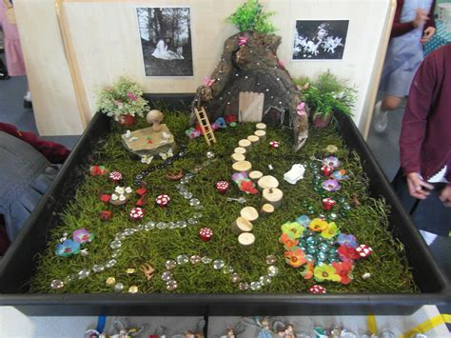

Music
https://www.youtube.com/watch?v=oWgTqLCLE8k

PE

https://www.youtube.com/watch?v=BQ9q4U2P3ig

https://www.scoilnet.ie/pdst/physlit/fms-activities/dodging/

SPHE
Why not make a card for a friend and send it.

Religion
Why not ring a grandparent or someone you haven’t seen in a while and pray the rosary with them.

