Mrs Keeve’s Work List 11th May
Hello Boys and Girls. I hope that you are all doing well. We will be doing some work on construction this week. My class have loads of experience with construction. Remember the kites, the hangers, the wind turbines, the solar system, so I know you will be superstars this week. I hope you are all keeping well. Do what you can, I am not expecting every piece of work completed. Pick what suits you and your child.
English
Spellings-
Construction, debris, demolish, contraption, architect, engineer, extension, derelict, foundation, landscape, fabric, planning, welding, skyscraper, invention, division, divide, repeated subtraction, estimate.
Look up the words and try to put them in a sentence.

Reading and Oral Language

The Homework Machine
The Homework Machine,
Oh, the Homework Machine,
Most perfect
contraption that's ever been seen.
Just put in your homework, then drop in a dime,
Snap on the switch, and in ten seconds' time,
Your homework comes out, quick and clean as can be.
Here it is— 'nine plus four?' and the answer is 'three.'
Three?
Oh me . . .
I guess it's not as perfect
As I thought it would be.

Practise reading the poem aloud.
Circle the rhyming words.
You could create your own homework machine. Draw a picture or design and construct it.
Keep using oxford owl for reading and continue to read any library books you have.

Writing
Persuasive Writing - Should children do chores around the house?

Introduction - state your opinion

Reason 1 and example

Reason 2 and example

Reason 3 and example

Conclusion - restate your opinion

Maths
We will start talking about division this week. The best way to start is to buy a bag of sweets, get your child to count how many sweets are in the packet. Tell them we are now going to share them equally between you and another person. Let the child work at it themselves and if they figure it out, tell them they are dividing now. If they can’t work it out, give them some help. If there are sweets left over, explain to them that this is what we call our remainder.
Keep the division simple to begin with. Use berries, grapes, pasta, raisins, anything you have to get the children to complete these simple sums. By using these hands-on objects, you are creating a picture of division in the children’s heads. If you use something different every day the children get used to the concept before doing it formally in their copy. It also teaches them that division is used in everyday life.
10 ÷ 2 12÷ 2 20 ÷ 2 16 ÷ 2 18 ÷ 2 14 ÷ 2 8 ÷ 2 Move on from ÷ 2 if your child has grasped it.
Try to show this using hands-on objects. You can also refer to halving the amount and that it is the same as ÷ 2.
Try to work on the Division Tables. Use this week to really try hard at them before we move on to harder division sums
https://www.splashlearn.com/division-games
Use you hundred square to look at repeated subtraction. How many times can I take 2 from a number. This is another way to divide.
For Example
10 ÷ 2 =
10 – 2 = 8
8 – 2= 6
6 – 2= 4
4 -2 =2
2 – 2 =1
Therefore I had to take 2 from 10 five times- 10 ÷ 2 =5

Try these using repeated subtraction
- 25 ÷ 5 2. 18 ÷ 6 3. 32 ÷ 8 4. 30 ÷ 5 5. 16 ÷ 4

If you complete all this work. You can try the chapter on division from Planet Maths page 58 folensonline. Also keep working on your mental maths book.
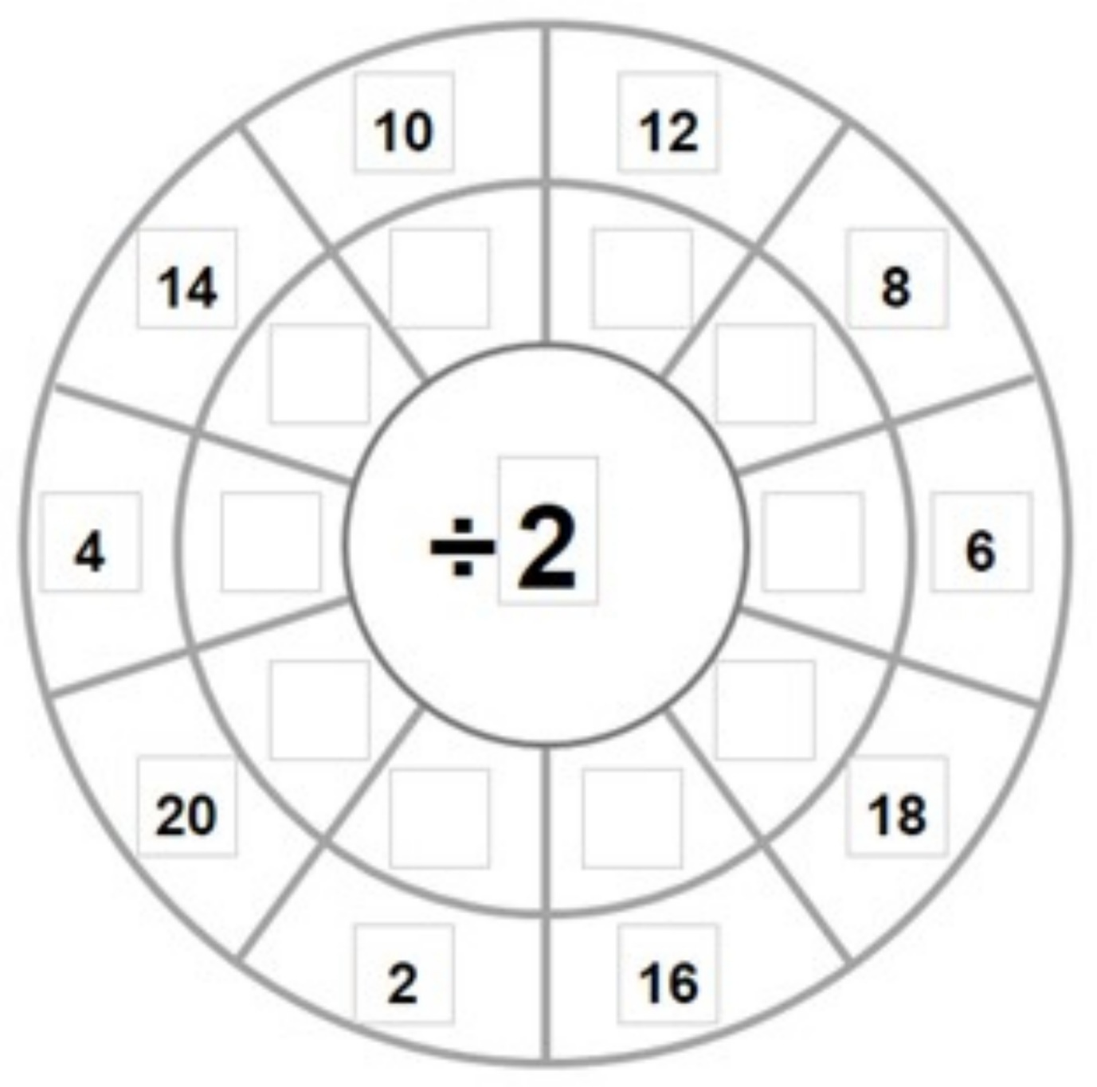

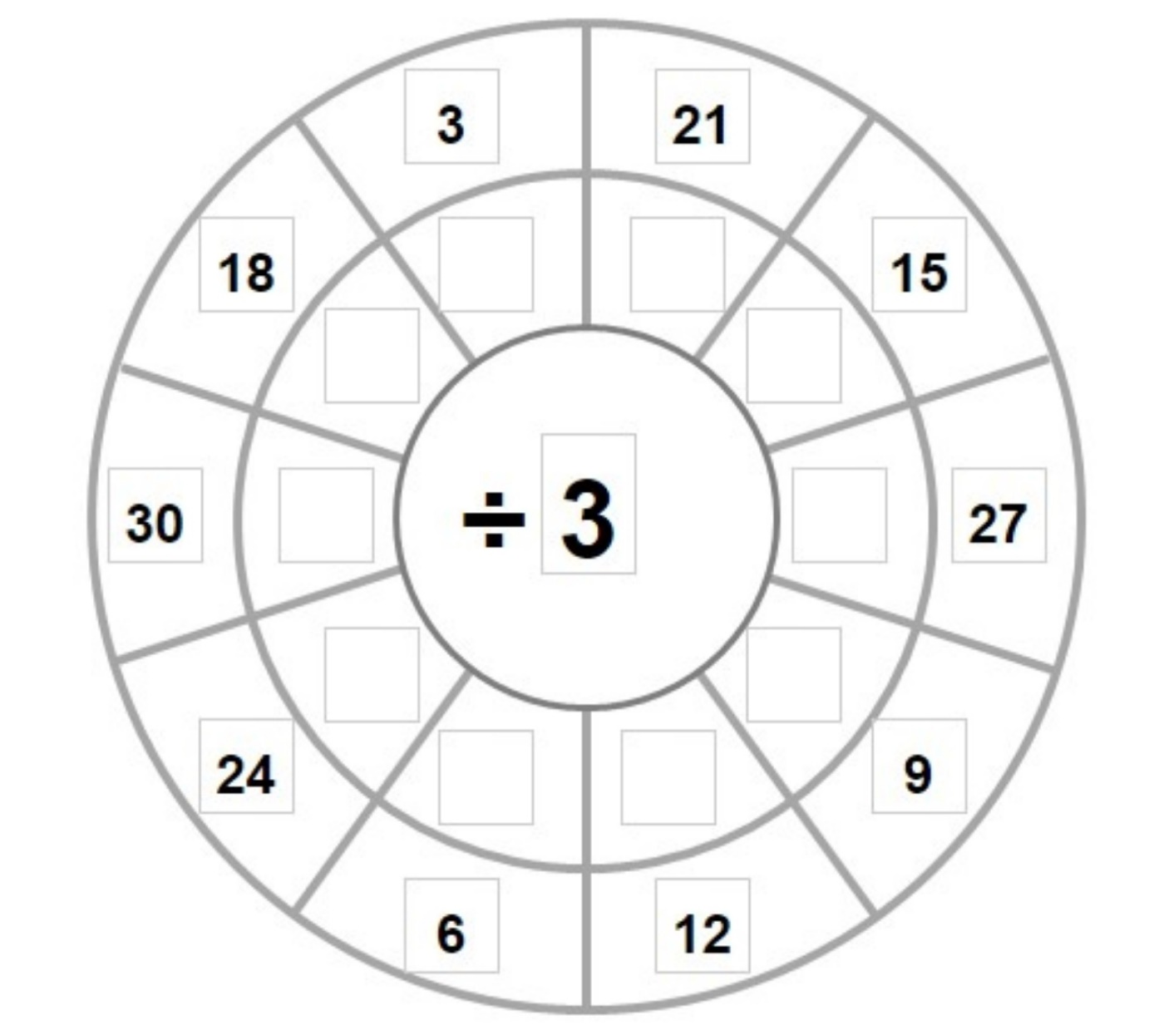
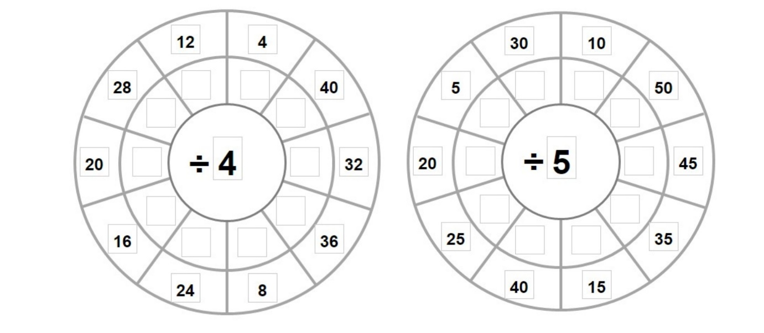

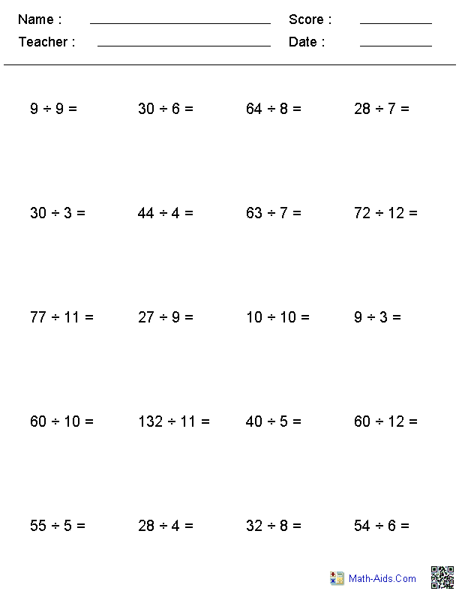

Gaeilge
Dia duit
Tá mé ar saoire i Spainn I am on holiday in Spain.
Tháinig mé ar eitleán I came by plane
Bhí mé tuirseach traochta tar éis an turas I was dead tired after the journey
Tá an aimsir ar fheabhas The weather is brilliant
Téim go dtí an trá gach lá I go to the beach every day
Beidh mé ar ais Dé Luain seo chugainn I will be back next Monday
Go dtí sin, slán
Write the above onto a postcard template or draw out a postcard. Draw a picture on the back of the postcard.
Everyone should try to read the postcard.
For spellings try to rewrite the postcard as much as you can. Some students might want to put in extra sentences that they know. You know the weather for example.
Postcards are something that always comes up in secondary school so having a bank of postcards will be very useful moving forward.
https://www.seideansi.ie/
A great website to practise Irish.

Geography
Pick a few famous constructions or landmarks and mark them in the world map.
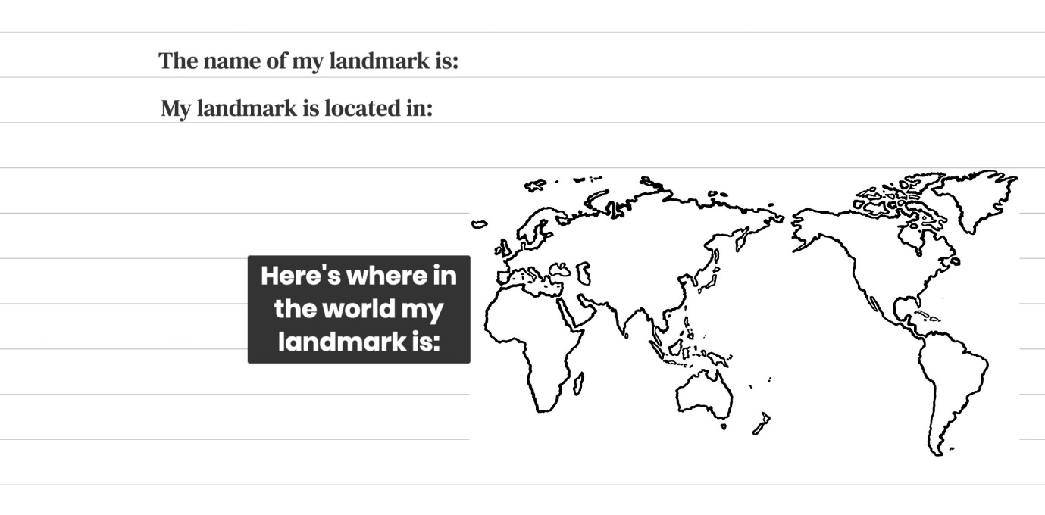

You can then draw a diagram or construct them using lego or something you have around the house.

Science
Design and Make- Some ideas for the Construction Challenge to help you
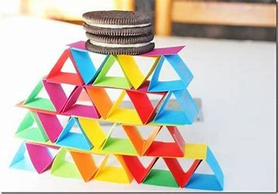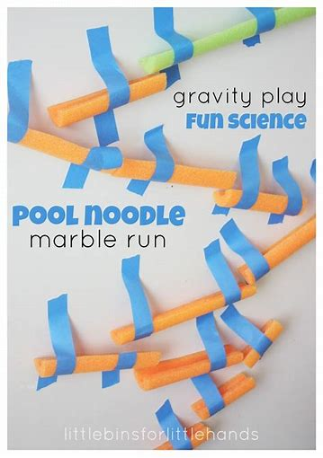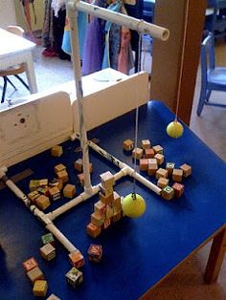
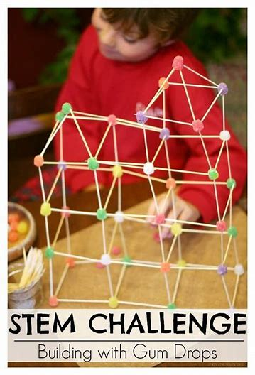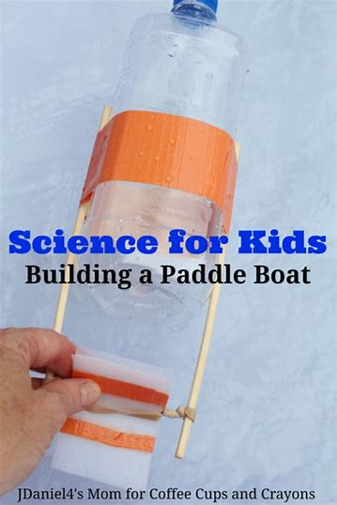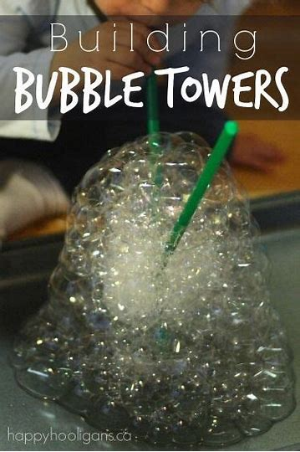

History
https://www.youtube.com/watch?v=qHygfkHD5TE
https://www.youtube.com/watch?v=T8mtY2GV_84
The Legend of the Giants’ Causeway.

Music
Look around the house and find some interesting sounds.
Try to make the sounds of the Rainstorm.
You could construct something that makes an interesting sound.

PE
Construct an obstacle course in your garden

SPHE-
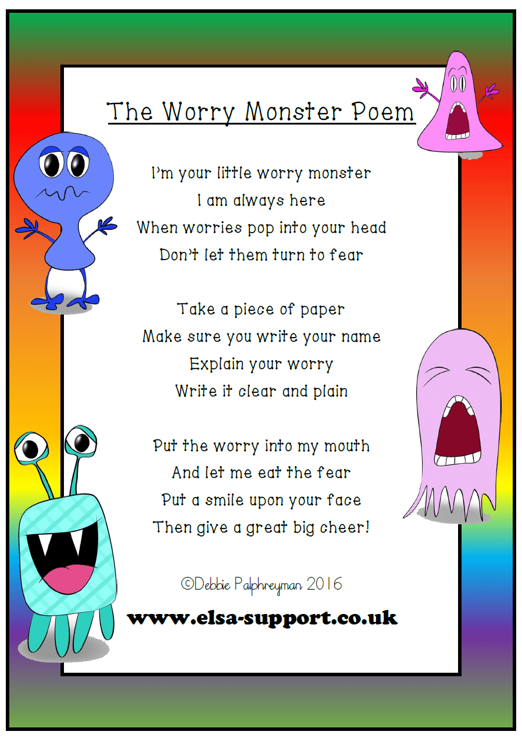
Get a jar and put eyes on it and decorate it as your Worry Monster. If you have a worry write it down and put it into the Worry Monster and the Worry Monster will help.

Religion
Hail Mary in Irish
https://www.youtube.com/watch?v=WSo1hr21PQM

Art
Use your coloured paper to create a paper construction. Be creative.
