Worklist for the 25th of May 2020.
Good morning everyone. I hope you all enjoyed Wellbeing Week last week. I think Outdoor Classroom week will be a fun, enjoyable week for you all. Hopefully the weather isn’t too bad. Remember that this worklist is a guide only, just do what you can and please do not feel under pressure to complete everything. I was again impressed last week with all the wonderful work that is being done at home. I have such a hard working class and I am very proud of them!

English
We have been working really hard on our tricky words and I liked seeing the videos of the children reading their tricky words on Seesaw. This allows me to see the great progress that they are making. This week we will concentrate more on revision of sounds and blending. Keep working on the photocopied book of sounds and words. Read the lists of words after each group of sounds.

Children can continue with free writing copies, drawing/writing what they are doing at home. Always remind your child to write in cursive when using their free writing copies. It is difficult but with lots of practice they will get there. Senior Infants can continue with writing sentences, take the theme of summer and try to use tricky words that they know.

This week we will revise group 4 sounds of Jolly Phonics group 4 ( ai, j,oa,ie,ee,or) Here is a video that revises the sounds and blending of these sounds in words. These videos are great if your child is struggling with blending or needs revision. https://www.youtube.com/watch?v=kYpRybeW-AQ

Parents can continue with Oxford Reading Tree to access their free ebooks library. Go to Oxford level 1+ and choose a book. Try ‘Ducks’. www.oxfordowl.co.uk
I would like to hear the children reading so I’ll have a book on Seesaw this week. We will also do a dictation activity on Seesaw this week. Call out the following words and get your child to write them. J infants: jam, rain, coat, pie, pork, bee.
S Infants: slug, paint, stork, float, sheet, magpie.

Gaeilge
We are still on the theme of ‘Bia’- Food. Our new phrase is ‘An maith leat? Is maith liom/ Ní maith liom. – Do you like…? I like… /I don’t like… Encourage your child to use this phrase throughout the week. The following are phrases we use throughout the day- dia duit, dia’s muire duit, (hello)
Conas atá tú? How are you? Tá mé go maith/Níl mé go maith. I am good/ I am not good. I will put these up on Seesaw along with songs and rhymes. Our poem this week is ‘Bí ag Ithe’.
Bí ag Ithe
Bí ag ithe. ( actions for eating)
Bí ag ól. (actions for drinking)
Seas suas. (stand up)
Suigh síos. (sit down)
Slán go fóill. (wave)

Maths-Children can continue to practice forming their numbers 1 -5 and if they can do this with no reversals work on numbers up to 10. Senior Infants can work on writing numerals up to 20. Use your number line if needed. Watch out for reversals.
This week we will work on patterns and sequence. Start with looking at patterns around the house, clothes items, wrapping papers etc Look at patterns orally, start by calling out a series of numbers/words and ask your child to repeat the sequence, start with 2, progressing to 3 for example:
- Cat,dog,dog,cat
- 3,6,3,6
- Apple,orange,pear
Children can collect leaves/petals outside and create their own pattern.
Senior infants should be able to extend their patterns to 2/3 elements. Make a pattern for your child using an ‘incorrect’ item, can your child identify the incorrect one and replace it? In your copybook/whiteboard draw patterns and ask your child to copy them. Try these patterns below.
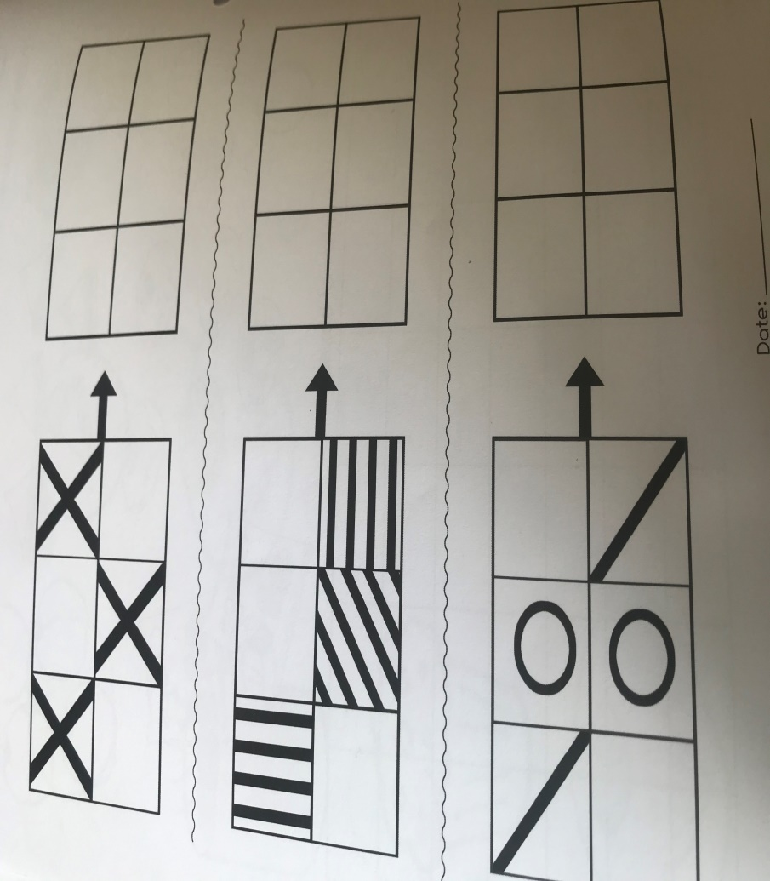
I have included some activity sheets on patterns below.
https://www.youtube.com/watch?v=6DDbzqYKNh0 A Numberblock video on sequence.
http://resources.hwb.wales.gov.uk/VTC/patterns_and_patterns/eng/Introduction/default.htm

S.E.S.E- Explore With Me The links for the slideshows/videos are at the top of each page online. Here is the webpage www.edcolearning.ie
Username: primaryedcobooks Password: edco.
History: Explore With Me page 56. ‘Seán Óg and Fungi’. Watch the animation and listen to the story. Look at the map of Ireland on p31 and show your child Kerry/ Dingle on the map. Ask your child to recall the main parts of the story. Questions; Where is Seán Óg from? What is his job? Who is Fungie? Why is he famous? What did Seán Óg do during the summer as a child? How have things changed? Talk about the picture and finish the sentences on p56.
Geography: Explore With Me page 55 ‘Summer is Here!’ Look at the slideshow and talk about the signs of summer. Go outside and complete p55. Draw what you can see, taste, hear, touch and smell. Talk about the different seasons, what are the trees like now? What were the trees like in Autumn & Winter? What is the weather like? What do people do in the summer? What clothes do we wear in summer?
Science: Explore with Me page 59 ‘Shadows’. If the sun is out, go outside and look for shadows. A shadow is created by light being blocked by an object. Shadows can be different sizes at different times of the day. Your shadow is longest in the morning and in late afternoon. Watch the animation, the children will hear the word ‘opaque’, explain that opaque is an object that blocks out light e.g a brick wall. Match the shadows on p59. Why not try drawing the shadows of toys.
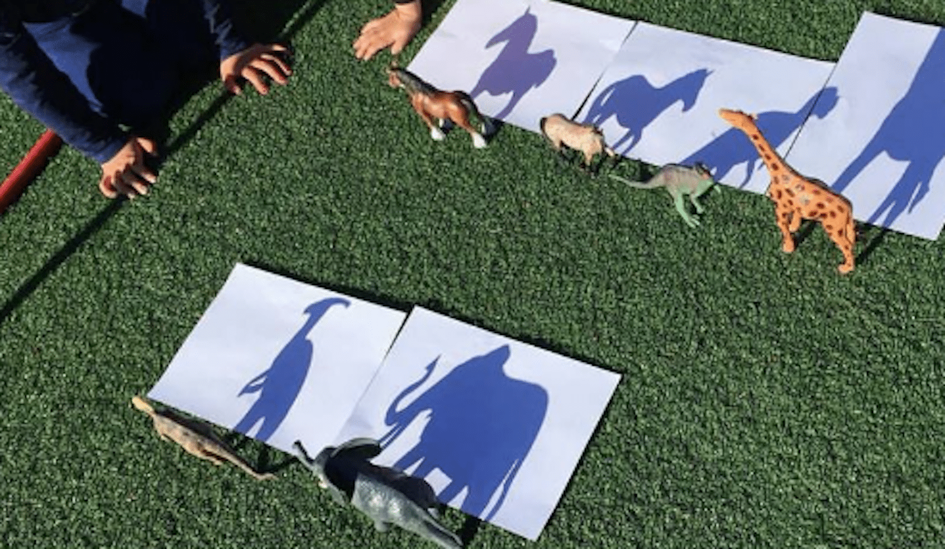

Music: This week I would like you to listen to and sing the song Mr Sun. https://www.youtube.com/watch?v=hlzvrEfyL2Y

Art: Go outside and draw something from your garden, use lots of nice colour. Trace over some leaves and look for lines. Have you spotted any patterns outside?
P.E: Outdoor Adventure activities- Go for a walk, teach directions left and right. Make up a treasure hunt using simple clues around the garden. Help your child create an obstacle course in the garden. Try a scavenger hunt where your child must find objects in the garden that begin with certain letters.
R.E: Grow in Love, parents can access lots of resources online, theme 10 Seasonal lessons ‘Mary’. www.growinlove.ie

Your email address: trial@growinlove.ie

Your password: growinlove
Don’t forget to allow your child lots of opportunities to play. Allow them to use their imaginations and be creative; don’t forget to send me photos through Seesaw! Try and get outdoors this week with lots of fun learning. Don’t forget to send through all photos on the Facebook page to be entered into the weekly draw! Have a good week everyone and have fun!
Take care everyone,
Mrs Mc Gahern.

