4th and 5th Class work- Week beginning 8th June 2020
Hi 4th and 5th class!
I hope you are all keeping well.
Below are your suggested work activities for this week. Please remember to only do what you can and set aside some time for exercise and relaxation. This week is Sports Week, so take some time to practice your School Sports Day activities. Continue to login to your Seesaw account also for extra activities this week.
*Please note also- Mrs O Connell will be in touch with her children individually this week via email*
Thank you all for the continued effort.
Take care
Mrs Conaghan

English
- English in Practice –pgs 38 and 39.
- Spellings for 4th and 5th class (sports related)
- Record the meaning of any words you don’t understand.
Monday- 1. athletics 2. competition
Tuesday – 3. spectator 4. challenge
Wednesday- 5. equipment 6. canoeing
Thursday- 7. badminton 8. aerobics
Friday- 9. equestrian 10. champion
- Procedural writing continued (writing instructions)
Your procedural writing task for this week (for all groups): Write instructions on how to prepare for Sports Day. In your procedural writing, include the title, equipment needed for e.g sack, potato, spoon, water, runners etc and the method/ instructions to follow. You can use the template below.
- Continue to set aside some reading time each day.
https://www.oxfordowl.co.uk/

Maths
- Master your Maths- Complete Mon, Tues, Wed, Thurs of the next week on pgs 48 and 49
- Planet Maths- Mental Maths activities and revision
- 4th class Planet Maths- pages 126, 127 and 150
- 5th class Planet Maths – pages 26, 27 and 52
(Please do only what you are comfortable with and try some sums from every mental maths activity if you can).
- Division tables- Please revise your 6÷ and 7÷ division tables. Practice counting up and down on the 100 square in 4s and 5s.
- Log on to FolensOnline and the planet Maths resources for some maths games and revision.
https://www.folensonline.ie/home/library/programmes/planet-maths4/resources/

Gaeilge
Spellings revision for this week- Ag obair
Monday- 1. banaltra (nurse) 2. gruagaire (hairdresser)
Tuesday – 3. garda (police) 4. feirmeoir (farmer)
Wednesday – 5. sagart (priest) 6. píolóta (pilot)
Thursday - 7. siopadóir (shopkeeper) 8. múinteoir (teacher)
Friday –9. saighdiúir (soldier) 10. fear an phoist (postman)

- 4th and 5th class: ‘Leigh sa Bhaile leabhar D’- Read pgs 7, 8, 10 and 11 (An Siopa Leabhar, ag cur síos ar an aimsir, La Baiste agus Craobh Ghinealaigh )
- Green reading group- Please search for ‘Leigh Sa Bhaile leabhar C’ and access the online book. Read pages 7, 8 and 10 (Bróga Nua, Is Páiste Beag Mise agus An Bhfuil caitheamh Aimsire Agat) and answer the questions orally at the bottom with an adult.
- (In order to access the book please login to the CJFallon website. Search for the book ‘Leigh sa Bhaile leabhar D/C ‘and Click on the online book)
https://my.cjfallon.ie/dashboard/student-resources
- Activity sheet below (Mise agus Mo Dhomhan)– Tarraing agus dathaigh (draw and colour)

PE
- This week is Sports Week so make sure to practice your school sports events–
- sprinting, long distance running, the long jump, the throw, egg and spoon race, 3- legged race, wheel barrow race, sack race.

SPHE- Water Safety
- Water Safety lesson below- Click on the click below
https://static1.squarespace.com/static/593f9c096b8f5b6f0ab3cade/t/5e2ec7c2ff2cf27efbe18aec/1580124111131/PAWS+3+ENGLISH+WEB.pdf
- Below are some water safety activities to complete. Please click on the link below and complete
http://paws.edco.ie/third-and-fourth-classes/

ART
- Make a Water Safety poster on A4/ A3 paper including some important points from Teachpaws.ie above and create your own water safety slogan.
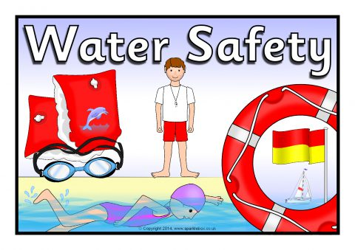

SESE
Science
Below are some Dublin Zoo fun activities, web cams and virtual tours. Click on the link below .
https://www.dublinzoo.ie/news/dublinzoofun/
History
Irish myths and legends activity. Read and then answer the questions. Click on the link below for the activity.
https://www.anpost.ie/NR/rdonlyres/8D649C45-5521-4799-B8DE-387F1262BC14/9580/IrishMythsandLedgends.pdf
- Extra activity- Choose another Irish myth or legend and draw your own stamp for An Post

PE
Continue to keep active and take plenty of breaks throughout the day to exercise
- The Body Coach- Joe Wicks on Youtube
- Movement breaks on youtube
- Create your own obstacle course outdoors and complete it as many times as you can. Get some family members to join in.
- Practice some school sports activities – sprinting, long distance, long jump, the throw, egg and spoon race, 3- legged race, wheel barrow race, sack race.

