June 1st
Senior Infants – Mrs Gallagher
Hi all,
I hope that you are all well and enjoying the fabulous sunshine. Here is the class work list for this week a 4 day week. Remember this is a guide only and you are free to pick and choose what suits you and your child. This week we are celebrating Science week. So send in your science pictures for the draw on Friday!

Reading –
I am going to give the children a reader from the CJ Fallon reading scheme for the next few weeks
The first reader is Hello and here is a link to the book
https://my.cjfallon.ie/preview/index/1430/1
Log on to CJ Fallon and click into senior infants, English readers, there is a list of readers to the right hand side and you can scroll down until you find Hello.
If you are enjoying the Monkey Pen books, here is one to read with your child this week.
If this doesn’t work just log into monkey pen.com and look for this book
Up In The Air

https://cdn.shopify.com/s/files/1/2081/8163/files/017-UP-IN-THE-AIR-Free-Childrens-Book-By-Monkey-Pen.pdf?v=1589849811

Language
Word Wise B – Oral Language page 79- Games
Mixed up sentences page 19
Complete the sentences page 24

Exercise Your English -
Oral language- Page 64 talk about the picture, what’s happening? What do you think will happen next? Draw the picture
Middle sounds page 65 (aou)

Spellings
pop
rug
sad
pup
fox
jam
sun
pot
rod
hat

This is your last spelling test this year so I hope you get them all right on Friday and make sure you get a treat for your hard work !!!!
Write a few sentences about a day at the seaside. You will have to use your imagination for this one guys but at least you have the weather.

Here is a link for a little song this week called summertime
https://www.youtube.com/watch?v=Xg5i9rxxuJM

I will be posting it on seesaw also. Why not give it a go and record yourself singing it back.
Irish –
You have the worksheets on éadaí to complete and I have sent another 2 pictures for you to dress. Ask a grown up to call out the teacher instructions. I will be reading them for you on seesaw.

This week I would like the children to listen to an activity as gaeilge from Seidin Sí
https://seideansi.ie/naionain-mhora/gniomhaiocht-1-dearg/ceim3.html

Handwriting Books
Try working on a page or two a week see how you are progressing.

Maths

This week we are all about number 11.
We are looking at one more than. You can ask your child oral questions about the number line, what comes after before? What is one more than?
Here is some mental maths that the children can do. Let them write down the sums or the answers. Make it fun by timing them. You can also call out the sums instead of writing them down. Here are some worksheets for the children to complete.
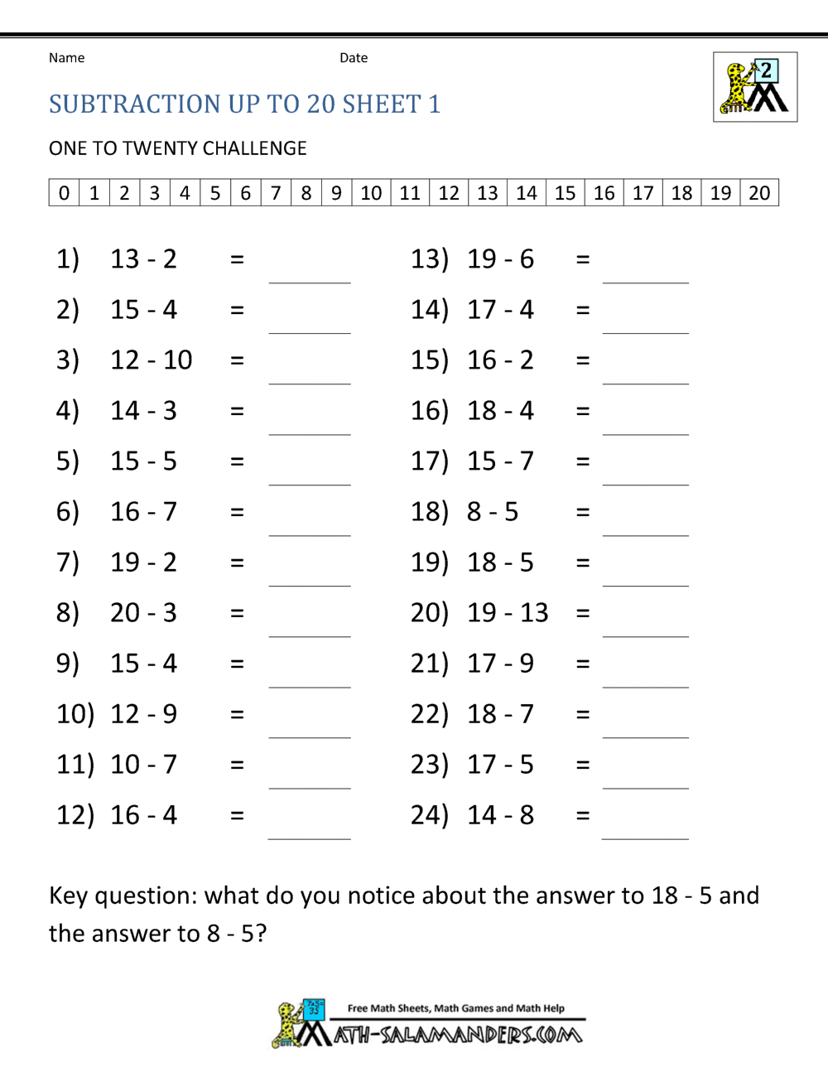
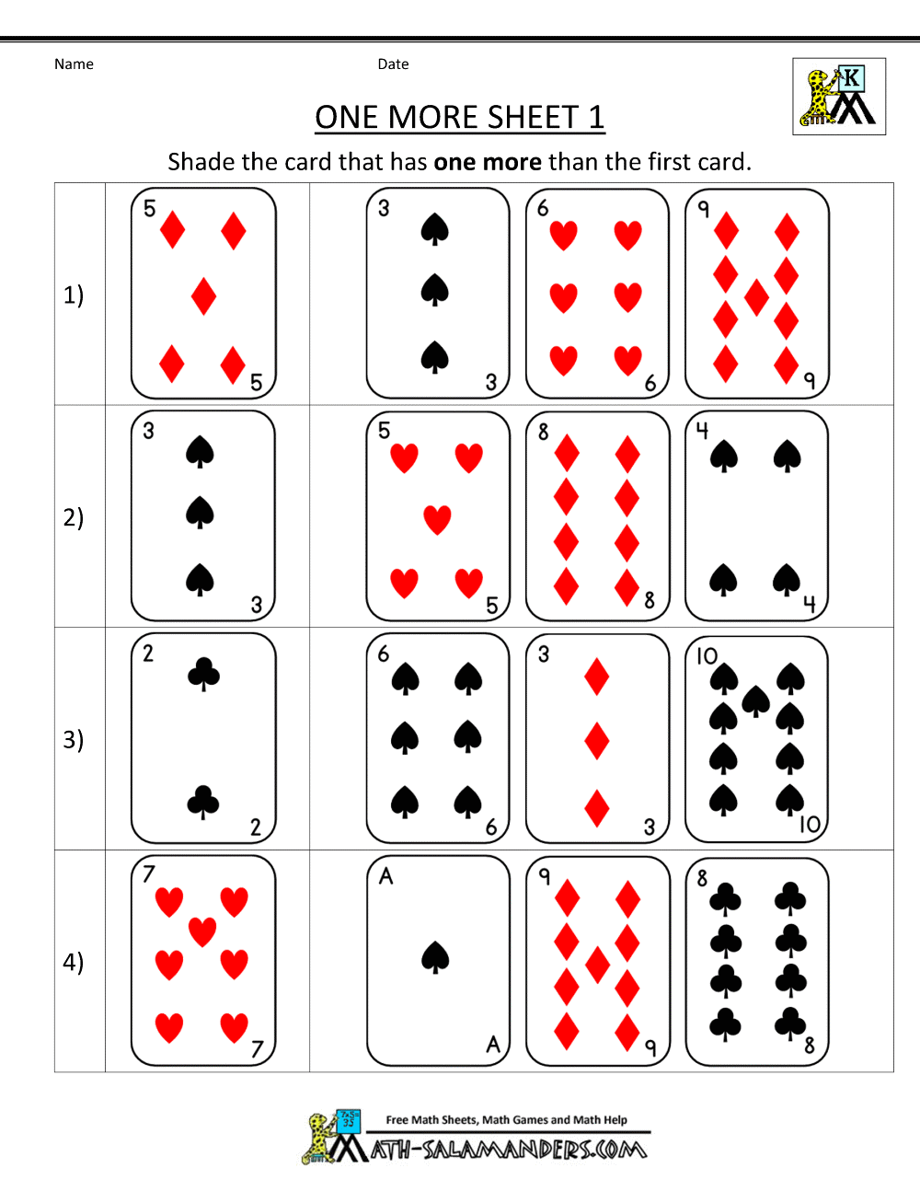
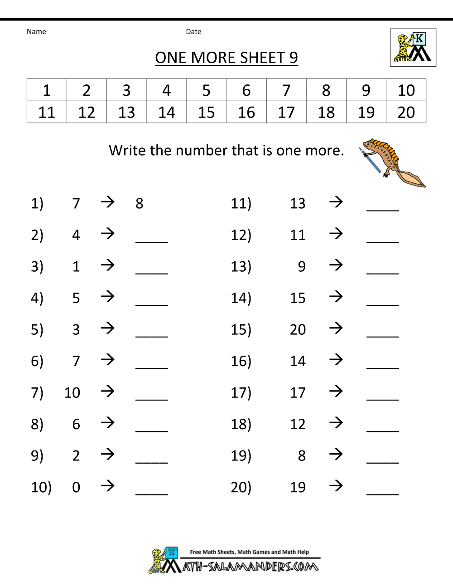
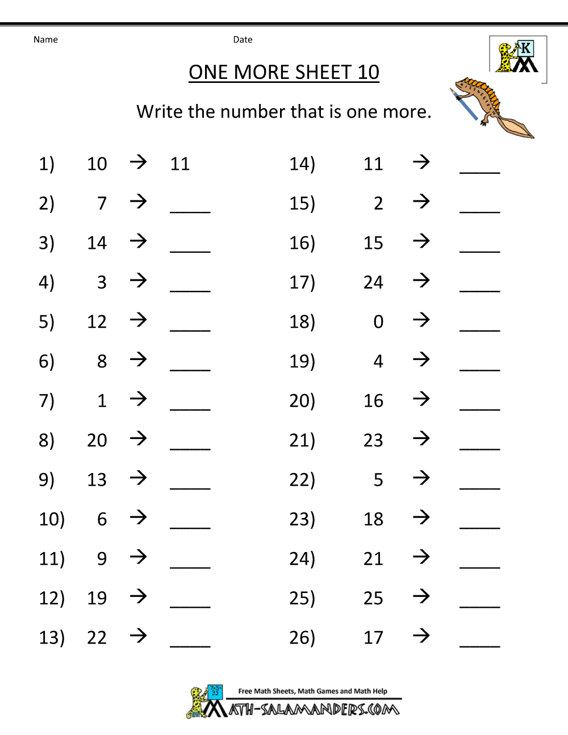
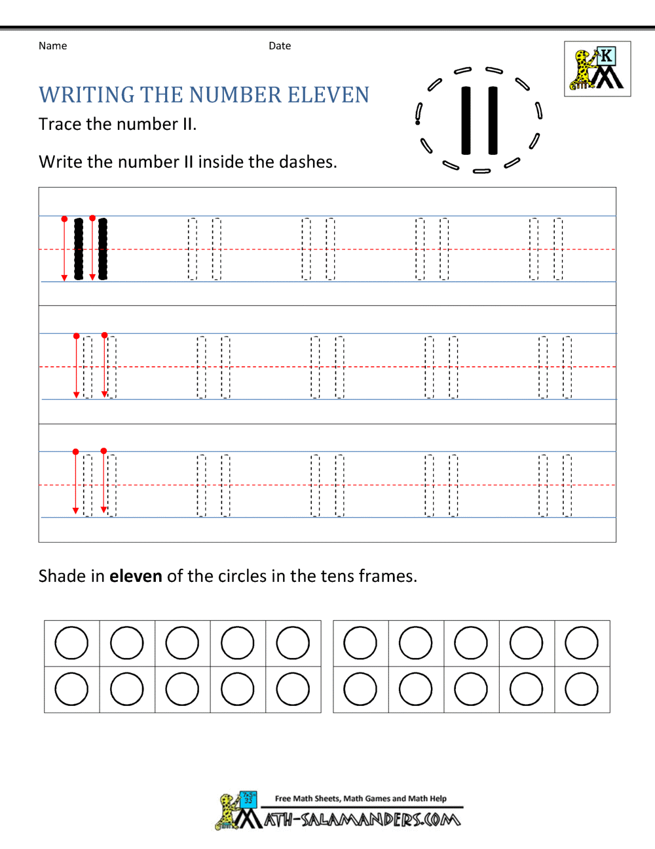

SESE – Science, history and geography
We are looking at Water again this week, so it’s a good time to be outdoors and experimenting with water, as its science week.
Explore with Me
Geography – pupils book page 58
What do we use water for each day?
How can we save water around the home? Especially when the weather is hot
If we were at school, how would we save water?
Fill out a water diary during the week to keep a list on how you use water in your home.
My Water Diary

Record the ways that you use water this week
Monday

Tuesday

Wednesday

Thursday

Friday

Science-
All about the Shark
Complete page 59 in the pupils’ book.

Listen to the book Commotion by the Ocean
https://www.youtube.com/watch?v=9pRhgZ8Jffs

As its science week this week why not try this experiment and send in a picture or video of you carrying out this experiment.
Floating sharks
Fill a small Ziploc bag or small plastic bag with water and one with oil.
Predict what will happen to each bag when placed in water.
Observe and discuss

History

Listen to and discuss the story of The Children of Lir. https://www.youtube.com/watch?v=sLJ6e7UzDek
Name the characters in the story and the places they lived.
Try and find Lough Derravaragh, the Sea of Moyle and Inishglora on a map of Ireland
Complete page 60 - The Children of Lir
Art
Draw a picture of the 4 swans in the cold water, remember how choppy the water is. Fill a basin of water and using bottle tops as the swans have a bit of fun during water play.

Our class e mail address is firstclass.steunans@gmail.com
Please do not hesitate in contacting me if you have any queries. Good luck with all the work, pick what you want and God bless.
Don’t forget to log into your seesaw account and take part in the activities during the week. Our class code is QUVXTSIT
Kind regards
Mrs Gallagher

Mrs McCaffrey has sent an e mail containing all her work to all her pupils.
Do not hesitate to contact her on her e mail if you have any queries.
Many thanks,
Mrs McCaffrey

