Worklist 2nd June Mrs Keeve’s Class
Hello Everyone,
I hope you had a great week with the outdoor activities. This week we are focusing on science, one of my favourites. I know you all really enjoy science too. Remember we do not expect everything on the worklist to be completed, do what you can.
English
Spelling – habitat, desert, adapted, camouflage, predator, carnivore, omnivore, herbivore, crust mantle, outer core, inner core, dinosaur, fossils, weight, gram, kilogram, science, experiment, investigate. (Children can look up these words.)

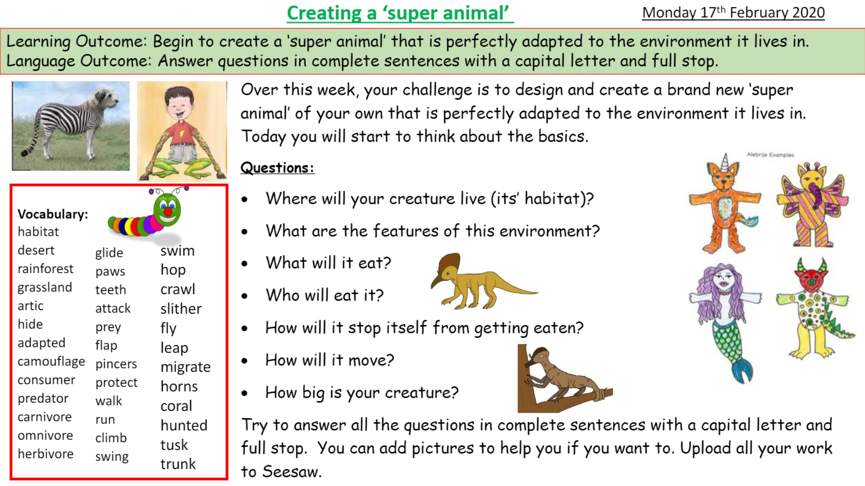

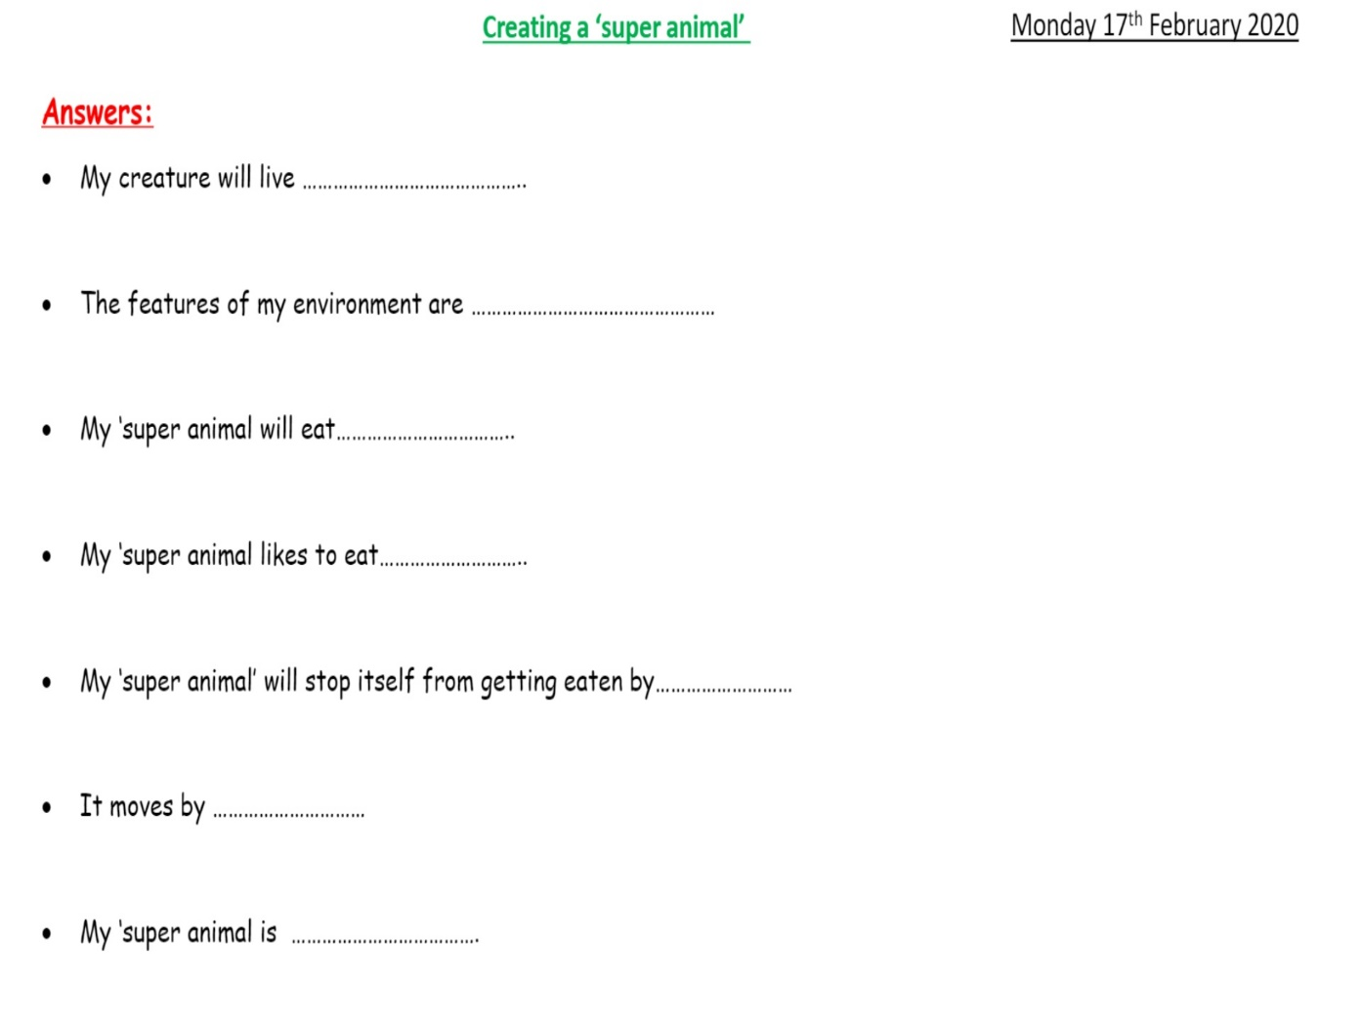Reading Continue to read library books and www.oxfordowl.co.uk.Read this poem and learn it to say for someone at home.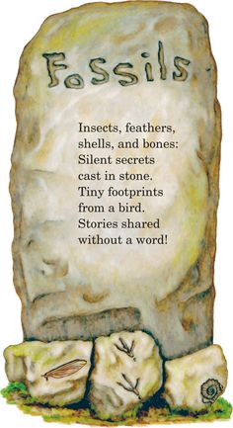

Oral Language – Talking Points

Maths
Again we are going to continue to work on division but also move on to weight.
Weight Facts to be learned
1000g = 1kg
½ kg =500g
¼ kg = 250g ¾ kg = 750g
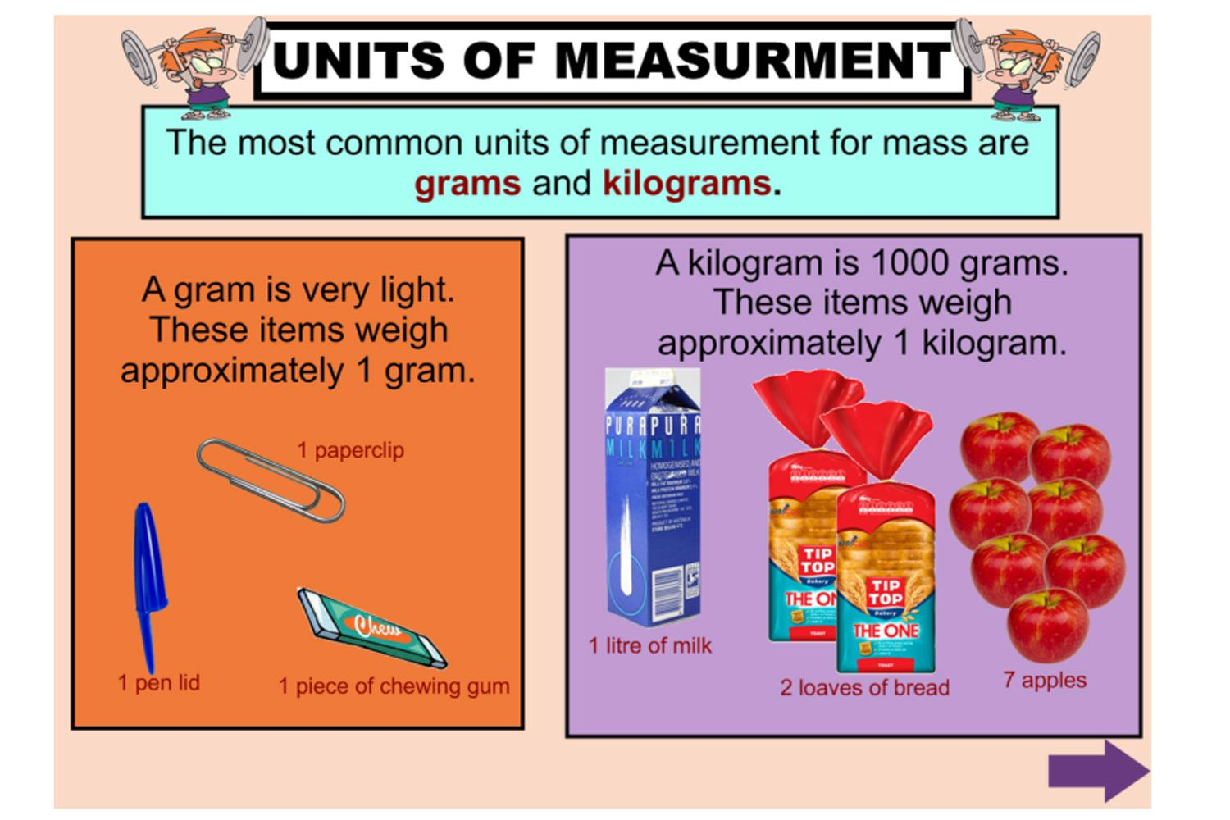

If you have a weighing scales weight some household things. Let the children play around with weighing things.
When they have got how to weigh, ask the children to find something that is close to 250g, 500g, 750g and 1kg.
Get the children to look at the labels of food items in the kitchen and compare the weight.
If 1000g = 1kg
How many grams in 2kg, 4kg, 9kg, 5kg, 8kg, 2 ½ kg, 6 ½ kg, 7 ½ kg, 4 ¼ kg, 5 ¼ kg, 3 ¾ kg
Look at food labels to find things that are over 1kg e.g. a bag of potatoes.
Decide which unit of measurement, grams or kilograms you would use to measure
- A football, a cow, a loaf, apples, the kitchen table,
https://www.youtube.com/watch?v=N_LG5EkU_a4
Order these weights from the lightest to the heaviest.
2kg, 750g, 4g, 500g, 2 ½ kg
800g, 34g, 500g, 1kg, 250g
7kg, 2000g, 5 ½ kg, 900g

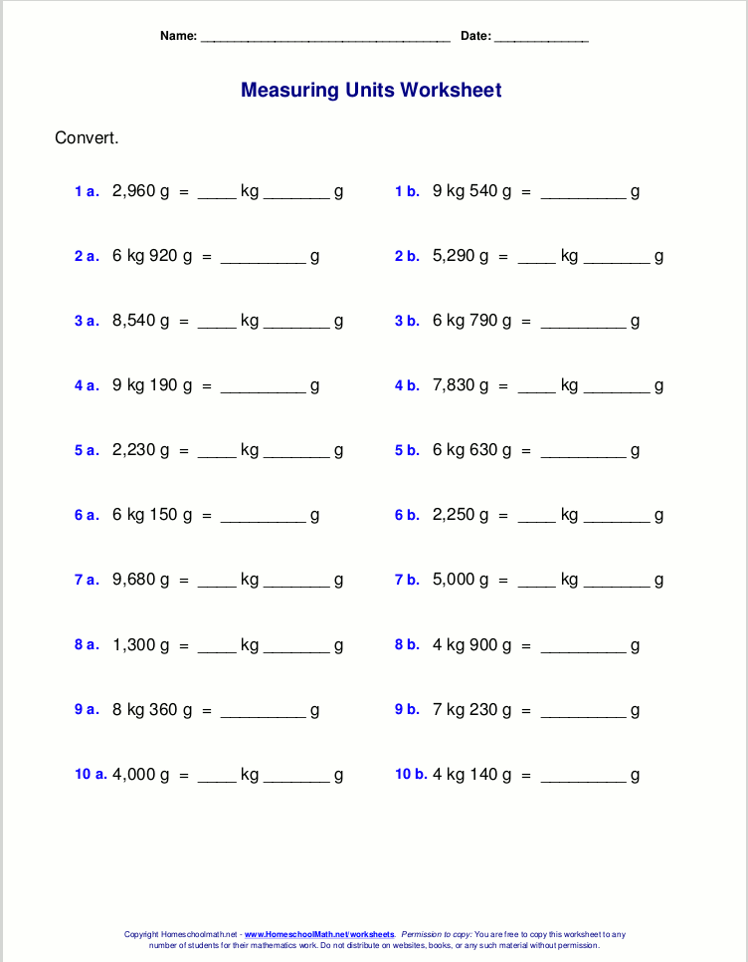

When adding or subtracting grams and kilograms, begin with the grams and then the kilograms.
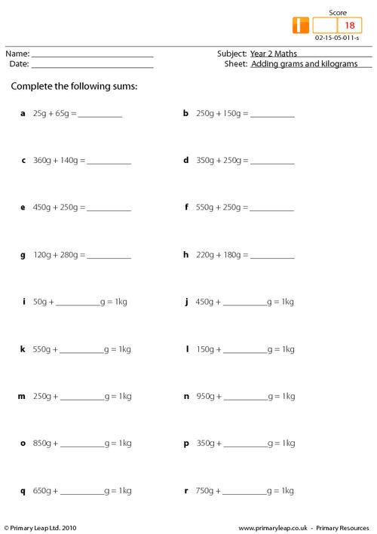

For more work on weight you can do the chapter on weight page 114 (3rd Class and 4th Class books).
Continue to work on mental maths.

For 4th Class
1000g = 1kg therefore 1g = 1/1000 kg
If a fraction is out of a 1000 you should have 3 numbers after the decimal point.
750g = 750/1000 =0.750kg
250g=0.250kg
In both of these you do not have a full kilogram, so it is 0.
If it was 1384g =1.384kg (You do have 1000g, so you have a full kilogram, so it is 1.384 kg)
Change these grams to a decimal of a kilogram
2500g, 450g, 899g, 3456g, 7650g, 645g
Change these decimals of a kilogram to grams
0.450kg, 8.790kg, 0.690kg, 3.566kg

Division Sums
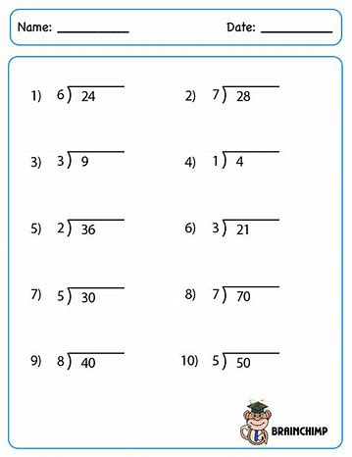

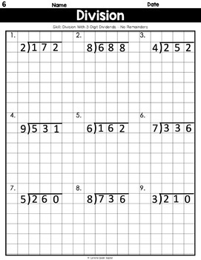

Gaeilge
Try to read this postcard first and then learn as much as you can for spellings.You should be able to add the weather to it or any other sentences.
A Dhaid Dear Dad
Tá mé ag scríobh chugat ó Sligeach I am writing to you from Sligo
Tháinig mé ar traein I came by train
Bhuail mé le buachaill/ cailín ar an tráI met a boy/girl on the beach
Bíonn an-chraic againn We have good fun
Téim ag snámh san fharraigeI go swimming in the sea
Beidh mé ar ais Dé Luain seo chugainn I will be back next Monday
Go dtí sin, slán
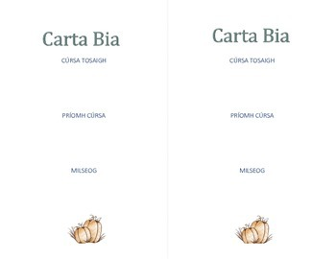
Fill in your own menu above-starter, main course, dessert

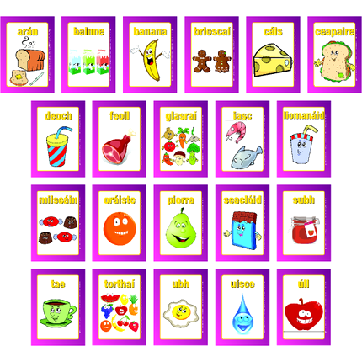
beans pónairí
boiled bacon and cabbage bagún agus cabáiste bruite
bread arán
bread roll rolla aráin
cabbage cabáiste
cakes cístí
carrot cairéad
cheese cáis
chicken sicín
children’s menu biachlár na bpáistí
fish iasc
fish fingers méara éisc
food bia
food served all day bia ar fáil an lá ar fad
ham liamhás
hamburger burgar
pizza píotsa

History

https://www.youtube.com/watch?v=G3gXWDYpLAE

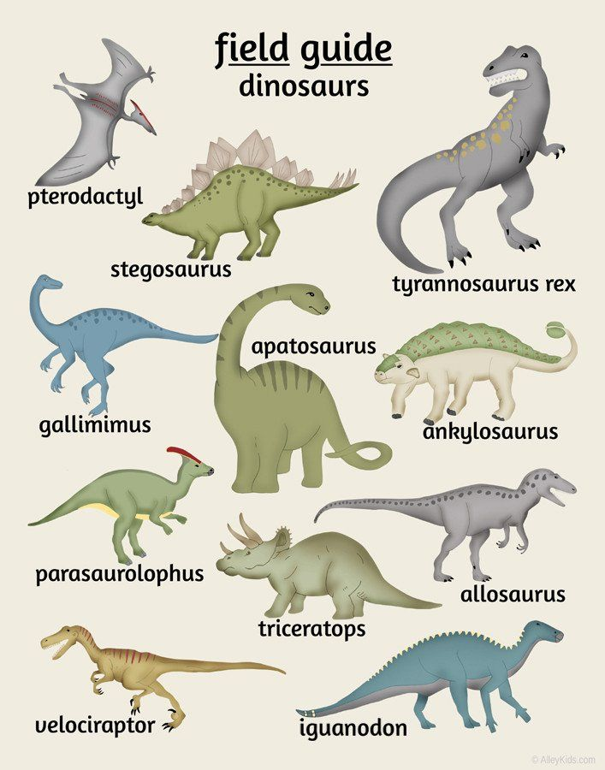

Pick a dinosaur and research some facts about it. Use the template of the Dinosaur Fact File.
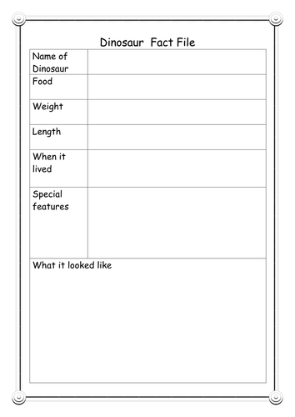

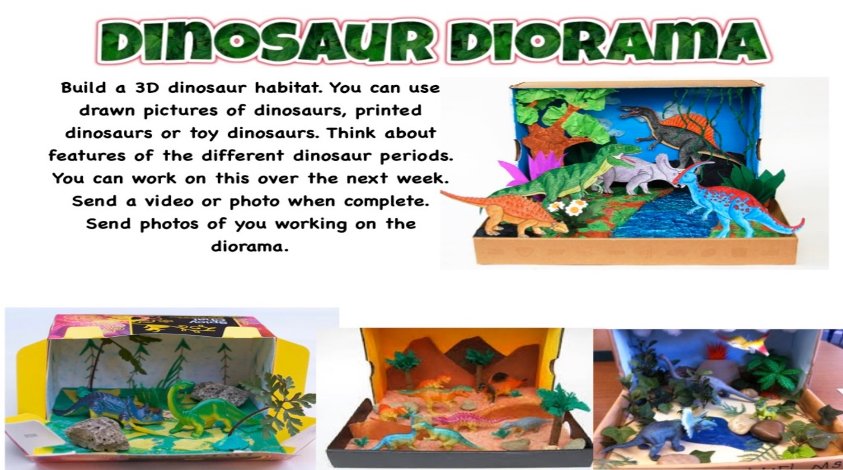

Geography

The Layers of the earth

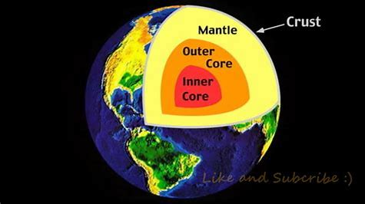

https://www.youtube.com/watch?v=WjXSCumeqxo

Make a model of the earth and the layers using play dough.

Science
There will be loads of ideas on facebook

https://www.sfi.ie/engagement/discover-primary-science-and-maths/activities-search/index.xml#result

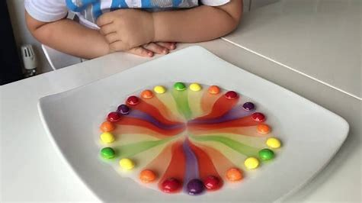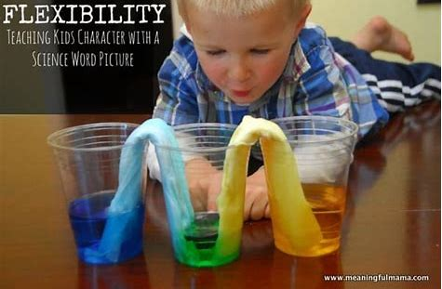

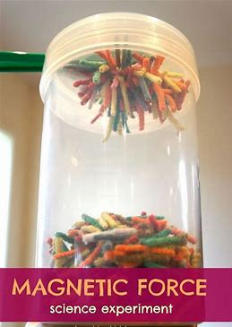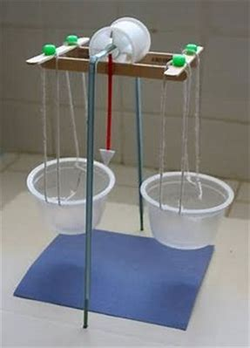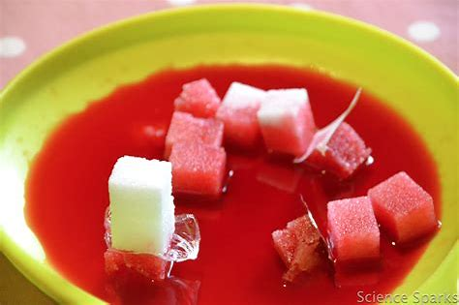

Music
https://www.youtube.com/watch?v=3-xKZKxXuu0
Listen to the sounds in your house and draw a symbol for them.
https://www.youtube.com/watch?v=F4xY0Pd9Hys&list=PLC02CFDE5690E4010&index=4

Art
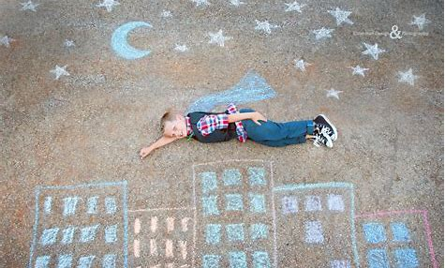

SPHE
https://www.youtube.com/watch?v=djxmuDz8c3s
Germs and hand washing

Religion
Pentecost
Draw a picture of the Holy Spirit coming down on the apostles. Read this prayer.
