Worklist 8th June- Mrs Keeve
Hello Everyone,
I hope you are all well and ready for Sports Week. It is very important that you all enjoy the races and have fun. We would love to see your clips. This week we will base our work around our Virtual Sports Day theme. Remember you do not have to complete all the work on the work list.

English
Reading Comprehension and Oral Language (work on reciting the poem)
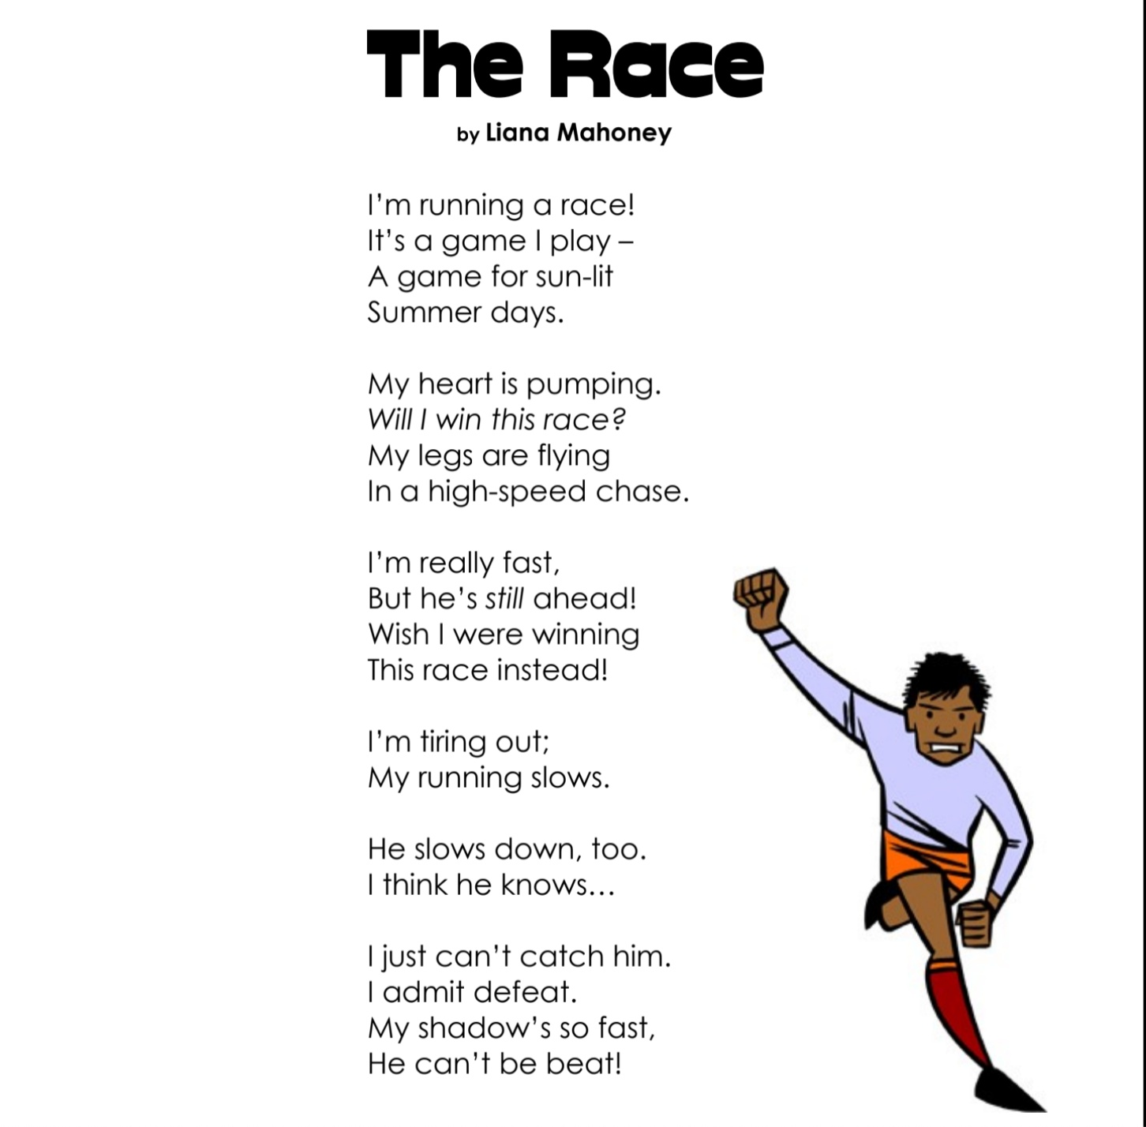
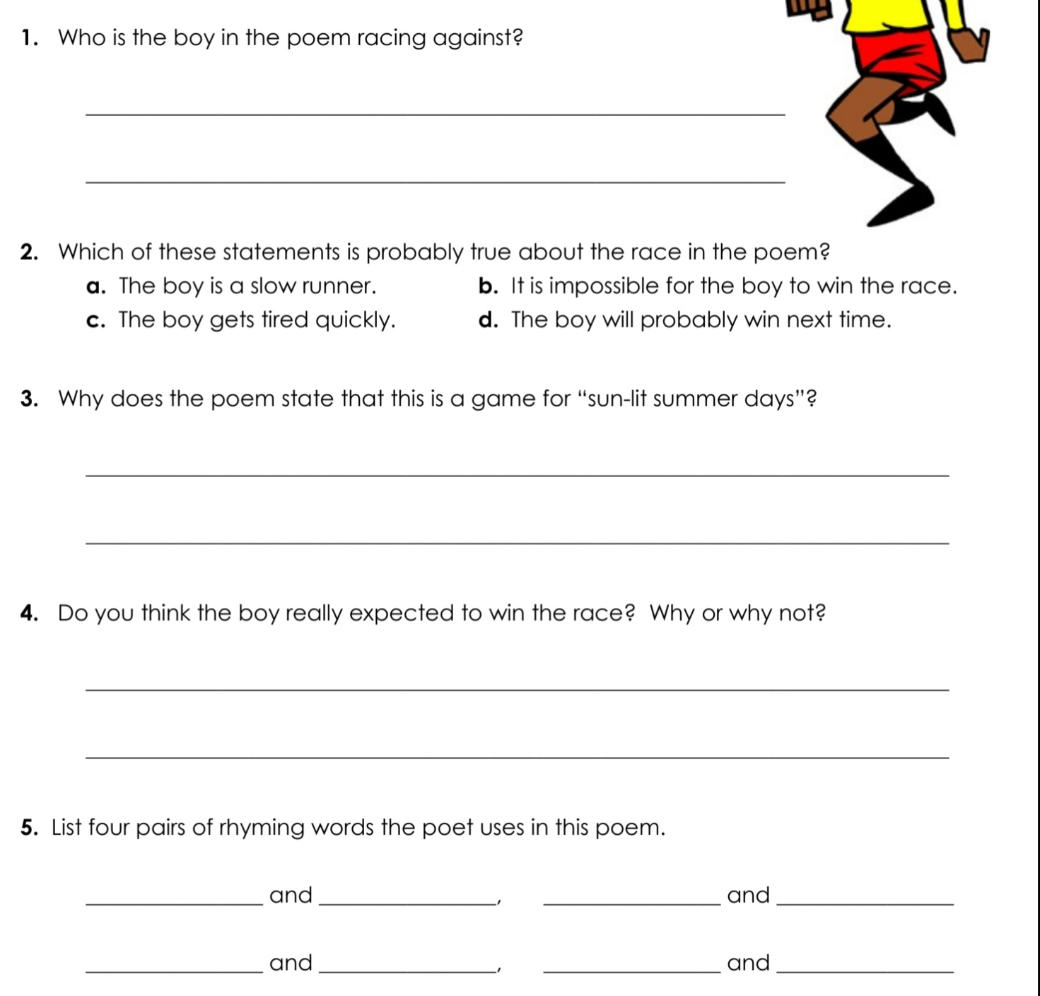

Continue to read library books and www.oxfordowl.co.uk.

Onomatopoeia definition is - the naming of a thing or action by a vocal imitation of the sound associated with it (such as buzz, hiss).

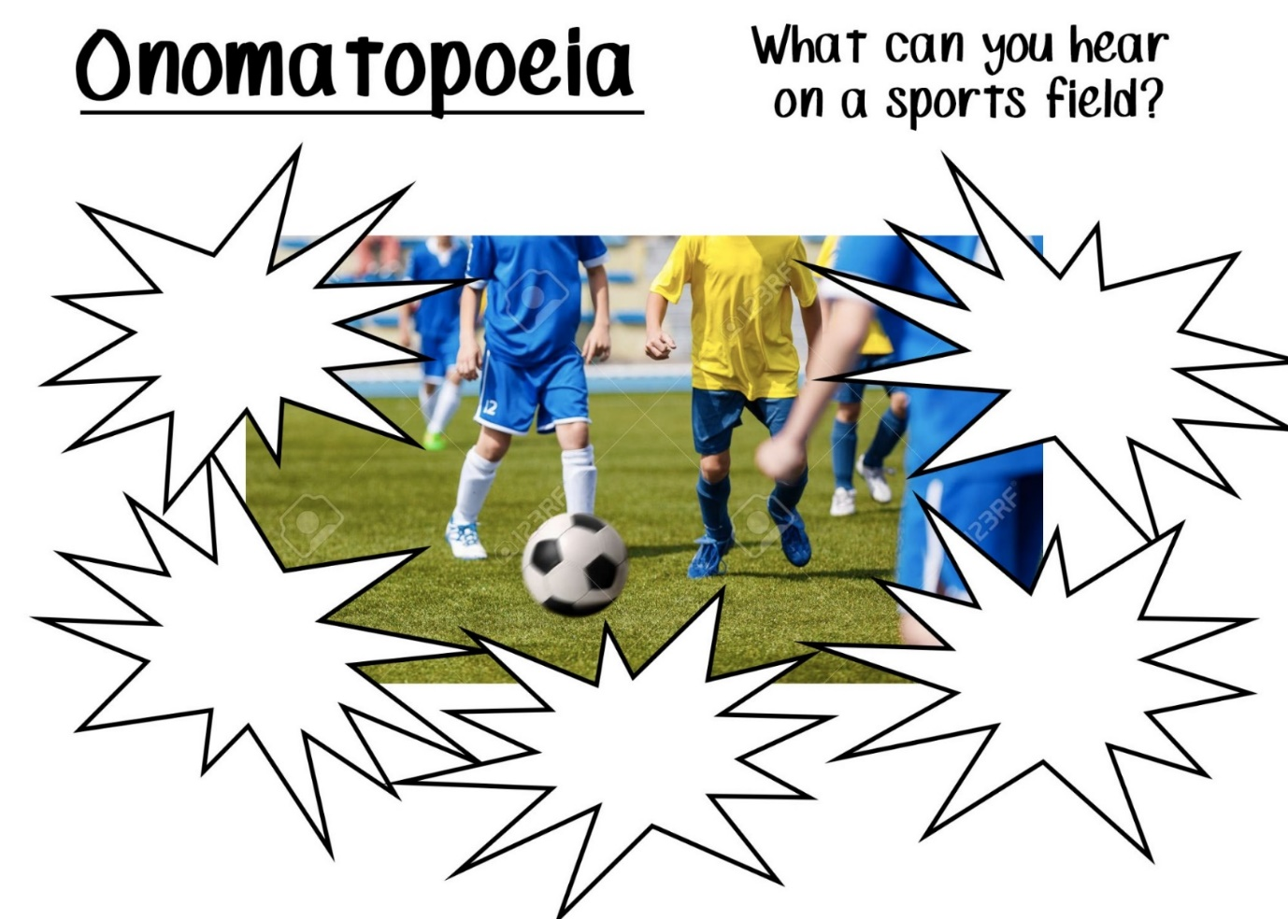
Spellings – Onomatopoeia, probability, chance, likely, unlikely, possible, impossible, certain, equipment, parachute, trampoline, referee, umpire, whistle, dedication, commitment, amateur, professional, championship, sportsmanship.

Maths
This week we will look at chance. I would like you to think about chance when you are running your races at home. Try to get other members of your family to take part. If one person seems to be winning a lot, maybe try and make the race harder for them, all the time thinking about chance. It can also make it more fun. Be creative. If the race is harder for them there is less chance of them winning. Experiment using different obstacles in your races and have fun. The probability of fun is likely.
Division Sums
68 ÷ 4 84 ÷ 6 57 ÷ 3 76 ÷ 4 96 ÷ 8

86 ÷ 6 99 ÷ 8 93 ÷ 7 87 ÷ 5 95 ÷ 3

344 ÷ 8 655 ÷ 5 732 ÷ 2 903 ÷ 3 752 ÷ 8 656 ÷ 8
Chance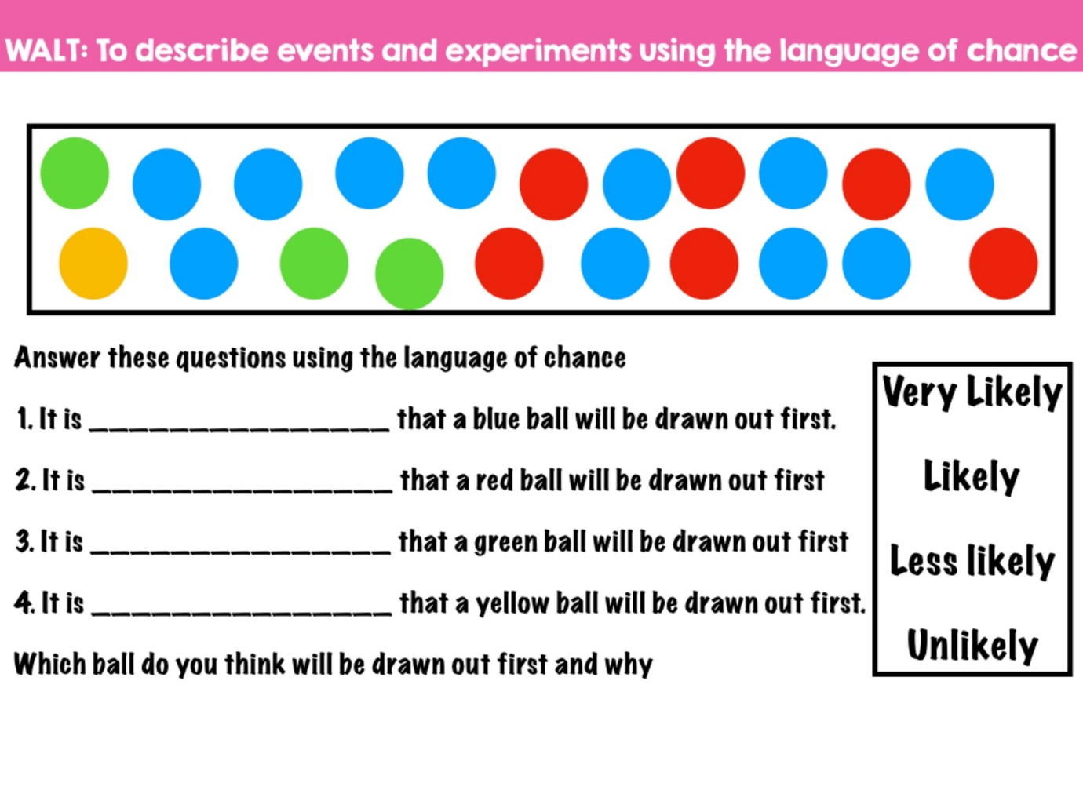

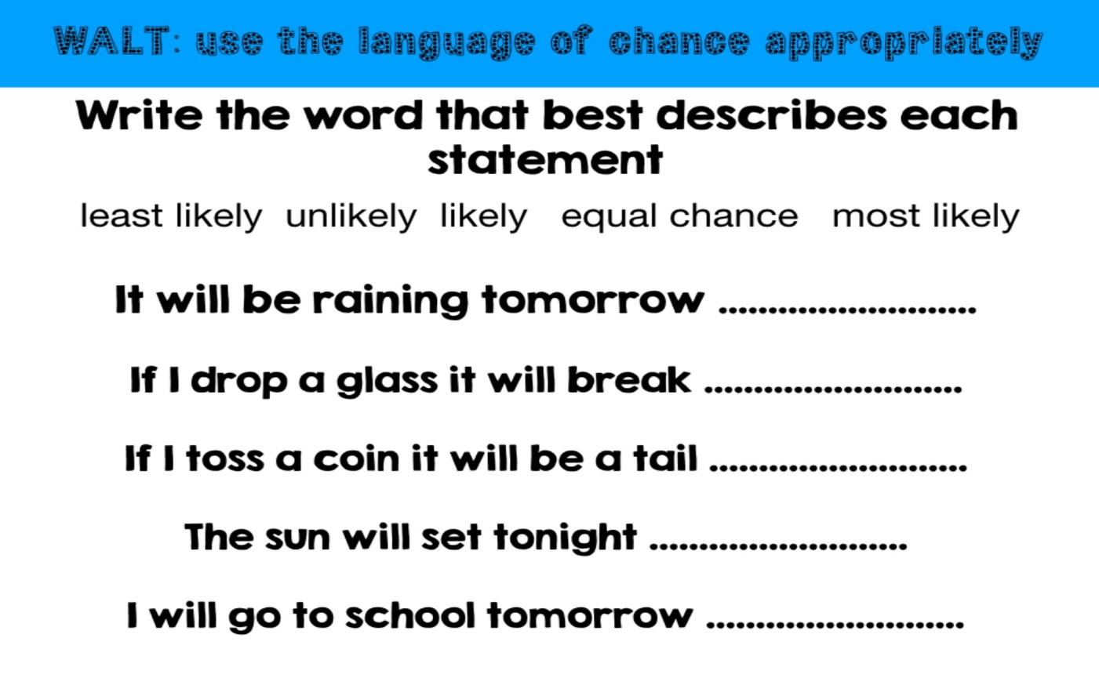

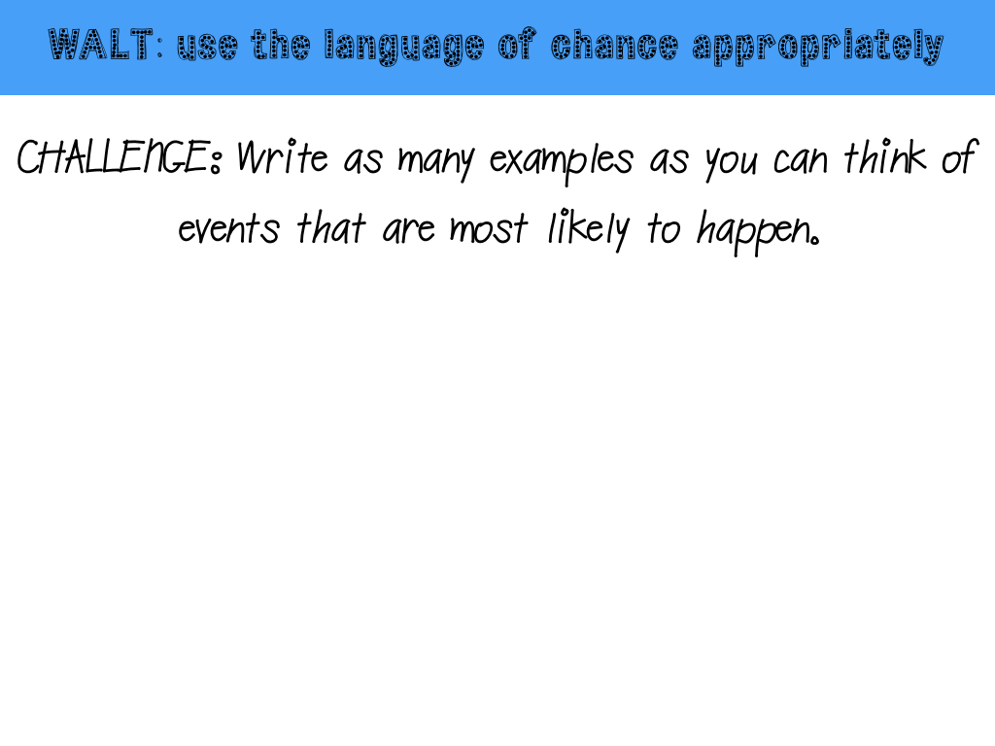
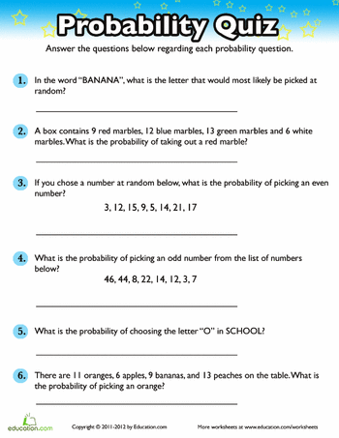

More work on chance can be found on page 95, Planet Maths for 3rd and 4th Class (www.folensonline.ie). Continue to work on your mental maths book.

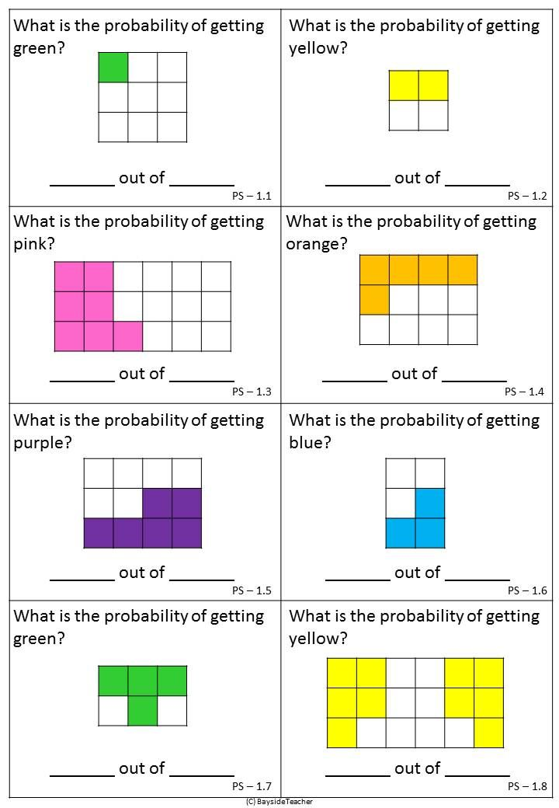

Gaeilge
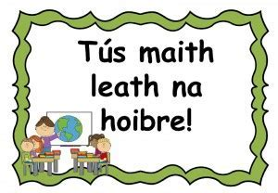A good start is half the work!

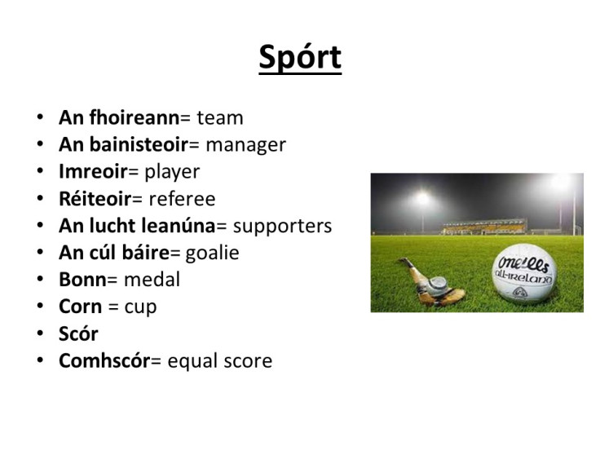
https://www.youtube.com/watch?v=jNTt0oAcoEQ
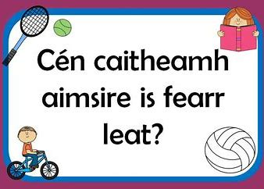

Dia duit…….Hello…………..
Táim i mBaile Átha Cliath. I am in Dublin
Tháinig mé sa charr I came in the car
Níl an aimsir go maith The weather isn't good
Chuaigh mé go dtí Cluiche Ceannais na hÉireann I went to the All-Ireland Final.
Bhuaigh Dún na nGall. Donegal won
Tá áthas an domhain orm.
Slán bye
Work on reading the postcard and use it for spellings. Try to learn as much as you can and you could use the words above to add to the postcard.

History
The story of Setanta
https://www.youtube.com/watch?v=vqyVElvBtE8

Research the history of the GAA.
Geography
Revision of the counties of Ireland

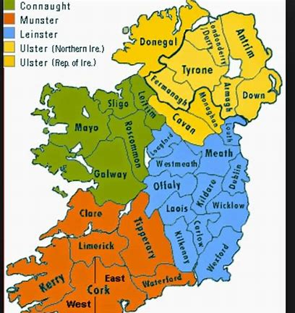

Science

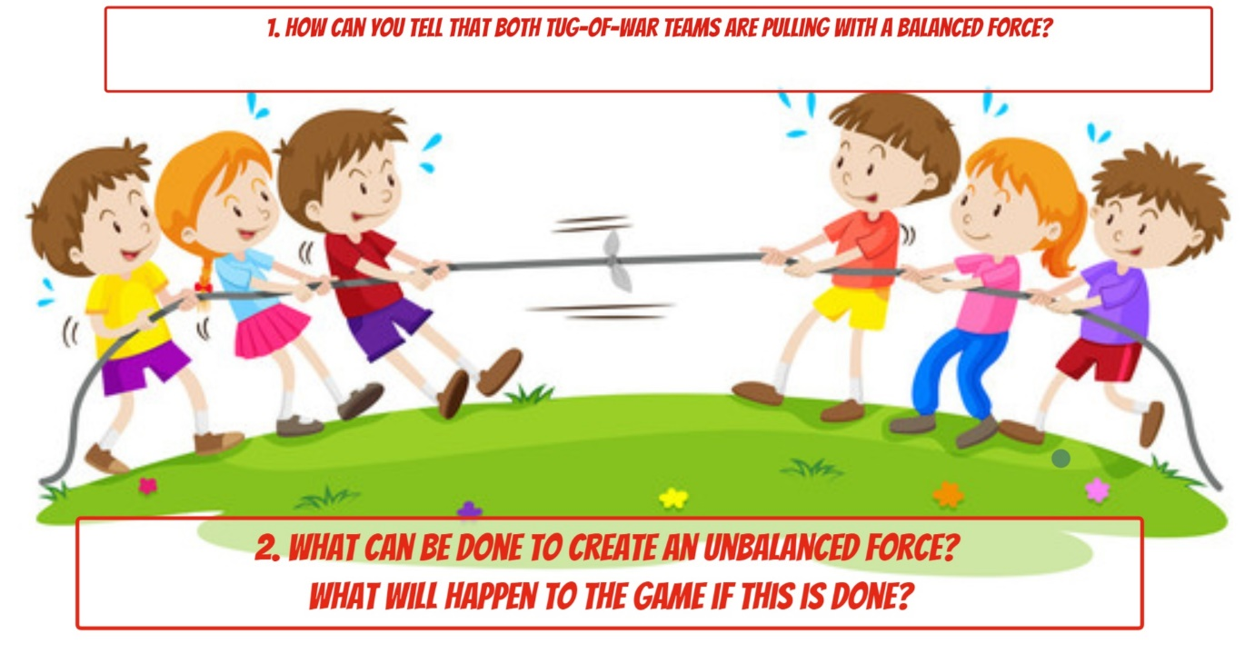
https://www.youtube.com/watch?v=y6VjHcOX8_o
Make a ramp at home and test different objects rolling down the ramp. It can be a small ramp. Find out which objects go the longest distance. Try to think of reasons why!
What forces would make people run faster in a race?

Music
https://www.youtube.com/watch?v=Az7dWrK2U48

Art
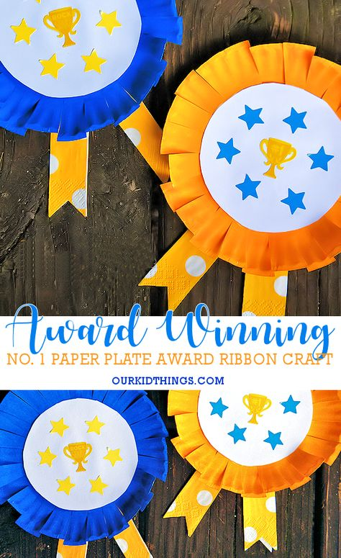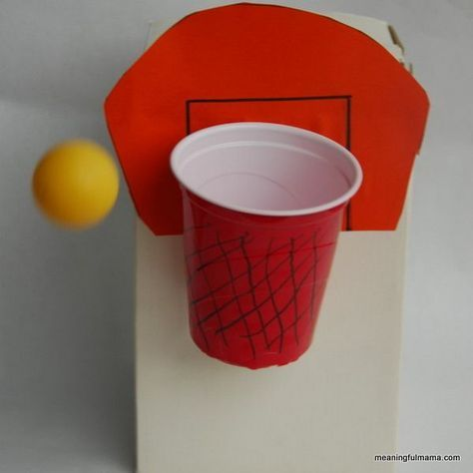
PE
Races on the Facebook Page for Sports Week.
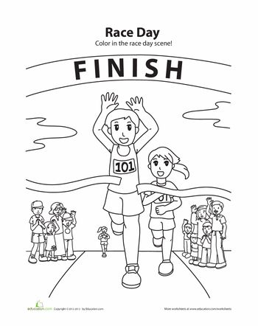

Religion You might want to go over some prayers at this time or learn new ones.

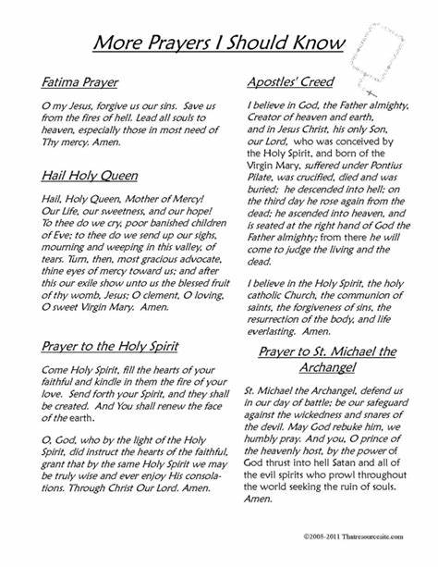

SPHE
