Worklist for 2nd of June 2020.
Good morning everyone,
I hope everyone is keeping well and that you all had a lovely enjoyable bank holiday weekend. It is hard to believe we are in June already! I hope everyone enjoyed Outdoors Classroom week, the weather was good which always helps! I loved seeing all the amazing work that is being done once again and of course seeing all the faces of the boys and girls in my class. I was very impressed with the sound scavenger hunts, the shadow drawings and the amazing dens that were constructed! Excellent work as always from my class! This week is Science week, which I think will be another fun and exciting week for you all.
English
This week we will revise another group of Jolly Phonics sounds ( qu,ou,oi,ue,er and ar) Here is a link to a video of the sounds and blending. https://www.youtube.com/watch?v=sCN4fogLmTo
We will also try Dictation this week again. This is something new and it will take time for the children to get used to it. Parents of Junior Infants can call out the following words and ask your child to write them in a copybook. Dictation words for Junior Infants: quit, out, soil, blue, mixer, car. Dictation words for Senior Infants: quilt, about, boil, glue, baker, star. These can be sent in a photo through Seesaw.
Thank you to the children who have sent videos of themselves reading their tricky words. Those who haven’t can still do this. Keep working on the photocopied book of sounds and words. Read the lists of words after each group of sounds.
Children can continue with free writing copies, drawing/writing what they are doing at home. Always remind your child to write in cursive when using their free writing copies. It is difficult but with lots of practice they will get there. Senior Infants can continue with writing sentences and try to use tricky words that they know.
Parents can continue with Oxford Reading Tree to access their free ebooks library. Go to Oxford level 1+ and choose a book. Children can even listen to these books. www.oxfordowl.co.uk

Gaeilge
This week our topic is Caitheamh Aimsire/ Past Times. We are again using the phrase ‘An maith leat? Is maith liom/ Ní maith liom… I liked seeing the videos of everyone using their phrases, well done everyone! More new words this week are ‘liathróid/eitleán/bád/rothar/bábóg/carr. I will have recordings and videos on Seesaw, our poem this week is Car Beag Glas.
Car Beag Glas
Car beag glas.
Car beag buí.
Car beag dearg.
A haon, a dó, a trí.

Maths
We will work on Spatial Relations & Spatial Awareness this week. It is important to explore, discuss and develop the use of vocabulary of spatial relations. Example position: over, under, up, down, on, beside and in. The language of ordinal number is used to describe position in a line and it’s also used to sequence actions and events. The language we use is first, second, third and last.
Start by giving oral instructions for your child to follow. Example: ‘Walk to the kitchen table, where are you now?’ ‘I am standing beside/in front of/behind the kitchen table’. Encourage your child to use full sentences and the appropriate language.
Use coloured clothes pegs or pieces of lego and give more instructions for your child to follow. Example: Place the pegs in a row with the red peg beside the blue peg./ Place the pegs in a row with the red peg between the yellow and green peg. / Place the pegs in a row with the blue peg under the green one.
Use your child’s teddies; ask them to put them in a line. Discuss which is first, second, third and so on. Sequence common everyday activities. Example: In the morning, first I get up, second I get washed, third I get dressed. You can use this mathematical language everyday, when talking about games ‘Let your brother go first, I’ll go last’. When making a cake or dinner, ask your child ‘what will I do first?’ what will I do last? You could give instructions to the following sheet below, colour the 2nd apple green/ colour the first bun yellow etc
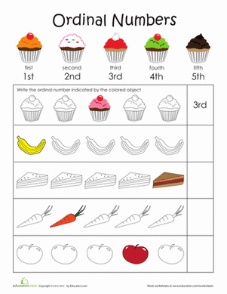

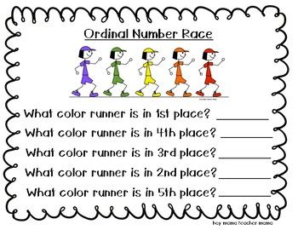
http://resources.hwb.wales.gov.uk/VTC/ordinal_numbers/eng/Introduct/default.htm

SESE- The links for the slideshows/videos are at the top of each page online. Here is the webpage www.edcolearning.ie
Username: primaryedcobooks Password: edco.
Science- I have included a few different Science experiments seeing that it’s Science Week so that you can choose which ever one you would like to try.
How butter is made p 54. Watch the video on how to make butter and try it yourselves! You will need a jar, a cup, a spoon and whipping cream. Pour the cream into the jar, explain that there is lots of fat in the cream. Ask your child to shake the jar, the particles of fat will stick together to form butter. The remaining is called buttermilk. Ask your child to explain how they made butter. Investigate where the butter would stay cool in your house? Where would it melt? Why? Making rice krispie buns is another way of looking at how materials change with heat.
Will the Orange Sink or Swim? You need 2 oranges, 2 glasses and water. Peel one orange and ask your child to predict what will happen.
Design and make Paper helicopters- all you need is paper!
- https://www.sfi.ie/site-files/primary-science/media/pdfs/col/paper_helicopters.pdf
Go on a Minibeast hunt in your garden-

Make a Vocano- There are lots of variations of this one online. I did it with my own children and it went down well.
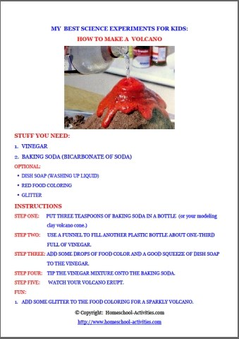

Make a Skittle Rainbow- This is another simple activity you could try. Arrange skittles in a circle around the edge of a plate. Cover the skittles in warm water. Predict what will happen.
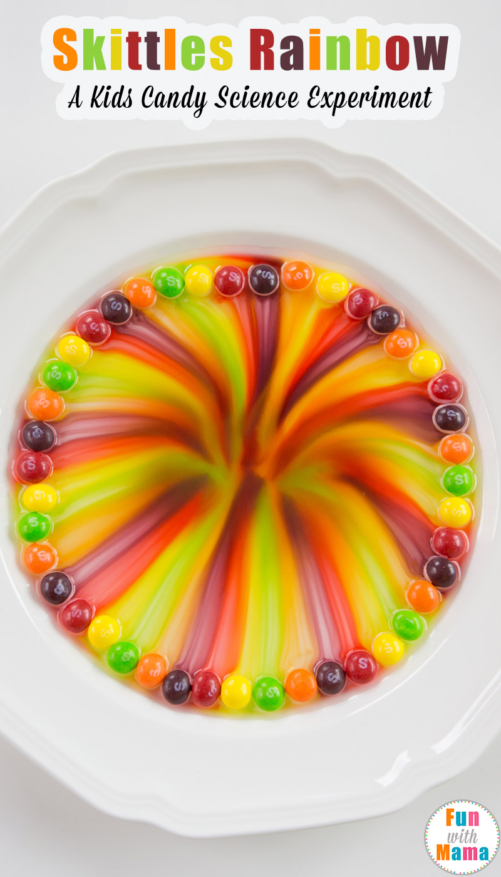
History- My Summer Holidays p60. Children can watch the slideshow and complete p60, recalling and recording facts about a holiday or a day trip that they have taken.
Geography- At the Seaside p57. There’s an interactive activity, children must sort items according to whether they can be found at the beach. In the book, children can label the pictures. Discuss with your child what they would bring to the beach, what they might see at the beach. New vocabulary: shore, rocks, seaside, sand, jellyfish, rock pool, seaweed, crab, sand dunes, starfish, shells.
S.P.H.E- Water Safety- Here is a link to a lesson on water safety. www.teachpaws.ie is a greta website for teaching children about water safety. A very important topic for this time of year. https://online.flowpaper.com/7efd0784/PAWS1ENGLISHWEB/#page=6

Art- Paint a picture of something you have done outdoors recently.

P.E Sending, receiving and travelling, ball handling skills- pass a ball or beanbag from hand to hand, through legs and around the waist. Balance- balance a beanbag on the palm of your hand/the shoulder, back of the neck, on the top of the foot etc Try walking/hopping while keeping it balanced. Walk around with the beanbag on your head without letting it fall. If you don’t have a beanbag, you can make one with an old sock and dried rice. Place the rice inside the sock, tie and knock and turn it inside out.
I hope that everyone has lots of fun learning at home this week. Science is so much fun so remember to take photos to record your investigations! The above is only suggested work for this week, please do what you can and parents never feel under pressure to complete everything!
Stay safe everyone,
Mrs Mc Gahern.

