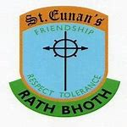

Dear parent/s, guardian/s and pupils,

I hope that you are all well and we are looking forward to welcoming everyone back to St Eunan’s NS. Junior Infants to 2nd Class will return to school on Monday 1st March 2021 and 3rd-6th class on Monday 15th March 2021.

Please ensure you have completed and signed the “Return to Educational Facility Parental Declaration Form” and return by email to the school or your child can bring it with them on the day.

I write to inform you of some of the arrangements regarding your child’s return to school. Please take the time to read the content of this letter fully and carefully.
All arrangements outlined in this letter have been approved by the Board of Management of the school. The arrangements are subject to change. We cannot foresee everything. Any changes that are necessary will be communicated to you in a timely manner.

This letter outlines practical steps which are being taken in our school to minimise the risk of the introduction of COVID-19 into the school.

Our key challenge is to balance the need for a practical and sensible level of caution with the need to provide a supportive and nurturing environment for teaching and learning.

The overriding objective is to protect the health of pupils and staff while promoting the educational and developmental needs of the pupils in the school.

The assistance and cooperation of all pupils, parents and staff is critical to the success of the plan.

Public health advice for schools is evolving but, in the event of a suspected or confirmed case, the school must follow the instructions of HSE Public Health - including informing any staff, parents or students who come into close contact with a diagnosed case via the contact tracing process.

All pupils, parents and staff are obliged to adhere to the procedures outlined in this letter. Each of us has a responsibility to adhere to these arrangements and to keep ourselves and every member of the school community safe and well.

The arrangements outlined are in accordance with all the advice from the Health Service Executive (HSE), the Health Protection Surveillance Centre (HSPC) and the Department of Education.

Each class will be known as a 'bubble'. Within the class bubbles from 3rd to 6th there will be 'pods'. These are smaller groups of pupils. The composition of pods may only be changed on a termly basis.

Each class bubble will stay as far apart from other classes/bubbles as it can. Pods within bubbles/classes will be separated by one metre. The objective is to limit contact and sharing of common facilities between pupils in different Class Bubbles (and different pods within those class bubbles) as much as possible.

The aim of the system within the school is that a pupil in a class/bubble will only mix with his/her own class from arrival at school in the morning until departure at the end of the school day. The pods within those class bubbles is an additional measure, to limit the extent of close contact within the class bubble. Pod sizes will be kept as small as is possible in each of our 3rd to 6th classes.

To the greatest extent possible, pupils and staff will remain in the same class bubbles throughout the school day. Different class bubbles will have separate break times and separate areas for play at break. Sharing educational material between classes and pods will be minimised. Staff members who move from class bubble to class bubble will be limited.

As far as is practicable each pupil will only come into contact with pupils from his/her own class from the moment they come through the school gate until they leave again. Each pupil will only come into contact with a small number of staff members. Each class will operate as an individual unit/bubble.

At home before school:
- every morning please check your child/ren for symptoms of COVID-19:
  - fever/high temperature – check your child’s temperature every morning
  - cough
  - shortness of breath or breathing difficulties
  - loss of sense of smell or loss of sense of taste

If your child or anyone in your child’s household is displaying any (even one) of these symptoms on any school morning do not send your child to school. Phone your doctor and follow HSE guidance on self-isolation.

Ensure that washing her/his hands is the last thing your child does every school morning before leaving home.

- Arrival:
In order to ease congestion at the school gate and to maintain physical distancing, you may drop your child anytime between 9:10a.m. and 9.30a.m. Pupils arriving after the traditional start time of 9.20a.m. will not be considered late. Pupils arriving before 9:10a.m. will not be allowed through the school gate and must stay in their car/bus until 9:10a.m.

Parents, and those dropping off children, should not congregate at the school gate.

On arrival pupils will immediately make their way to their classroom/bubble.
Supervision will be in place. Pupils will not assemble on the yards. Each pupil will sanitise or wash their hands as soon as they enter their classroom. Pupils in 3rd to 6th classes will move straight to their “pod”.

- In class:
The staff who work with pupils in each class/bubble will be limited to;
✓Your child’s class teacher
✓One Special Education Teacher. This Special Education Teacher will work in a small, limited number of classes/bubbles.
✓One SNA (where applicable).

If your child’s class teacher or SNA is absent a substitute teacher/SNA will be employed. Classes will not be divided up or split among other class bubbles.

Pupils will wash/sanitise their hands regularly throughout the day:
    - before and after eating
    - after coughing or sneezing
    - after using the toilet
    - where hands are dirty
    - when leaving the school
    - after touching potentially contaminated surfaces
    - if in contact with someone displaying any COVID-19 symptoms

Sanitiser will be provided at locations around the school. Pupils may bring their own small bottle of sanitiser with them to school if necessary. Please talk to your children about safely using sanitiser.

- Lunch times:
Please ensure that your child has a lunchbox and bottle that s/he can open and close with no help from a staff member. Spend time teaching your child to eat all items in his/her lunchbox. e.g. if your child has a banana, teach them to peel a banana.

It is essential that children have a lunchbox and take home any food they do not eat and all rubbish from their lunch. This will reduce the amount of movement between pods.

- Break times:
Break times for each class bubble will be staggered throughout the day. Each class bubble will have its own designated yard space for play during break times. Pupils from one class bubble will not be able to play or mix with pupils form a different class bubble.

During break times all the windows and doors will be opened to ventilate the classroom. A cleaner will also clean frequently touched objects and toilets.

- First Aid:
If your child requires First Aid, it will be administered by a member of staff and the staff member will wear a face covering.

Physical Education:
will take place as usual. Any equipment used will not be shared between bubbles before being cleaned or quarantined for 72 hours.

  - Uniforms:
Pupils wear school uniform as normal and we would recommend that pupils change out of their uniform when they get home from school.

-Pupils who have not yet learned to tie laces should wear Velcro shoes only.
-Ensure your child does not have unnecessary items in their school bag e.g. toys
-For now, coats will be kept in school bags or if not possible, on the back of chairs.
-Choose school bags, pencil cases, lunch boxes that are easy to wipe and clean.

  - Adapted Curriculum/Learning:
The initial settling back period will be important for revising and consolidating and, in some cases, relearning curriculum content previously worked on either prior to the school closure period or as part of distance learning. I would urge you not to worry unduly about any learning you feel your child may have missed during the school closure. Teachers are the experts in this area and they will know how best to recommence your child’s learning in school.

Initially teachers will focus on the key areas of literacy and numeracy. Social Personal and Health Education (SPHE)/Wellbeing and P.E. will also be key areas for teaching and learning.

- Visitors:
Only essential visitors will visit the school, the postman, HSE staff, staff from the National Educational Psychology Service (NEPS), the Department of Education Inspectorate and the Chairperson of the Board of Management will be allowed to visit the school. They may only do so with the prior approval of the Principal, Mrs Keeve or in her absence, the Deputy Principal, Mrs Mc Gahern. A contact trace log will be completed by each visitor every time s/he visits.
Parents may communicate with school staff by phone. Forgotten lunches etc. can be left at the Drop Off Area outside Mrs Rice’s office for collection. Please ring Mrs Rice to give her details about what you are leaving and your child’s name.

- School cleaning:
The Board of Management has employed a cleaner to meet our new enhanced cleaning requirements. The school will be thoroughly cleaned, disinfected and “fogged” prior to reopening. All classrooms and common areas will be cleaned every day after school. The Junior School will have a dedicated cleaner and the Senior School will have a dedicated cleaner. Particular attention will be given to toilets and shared commonly touched items and surfaces e.g. door handles.
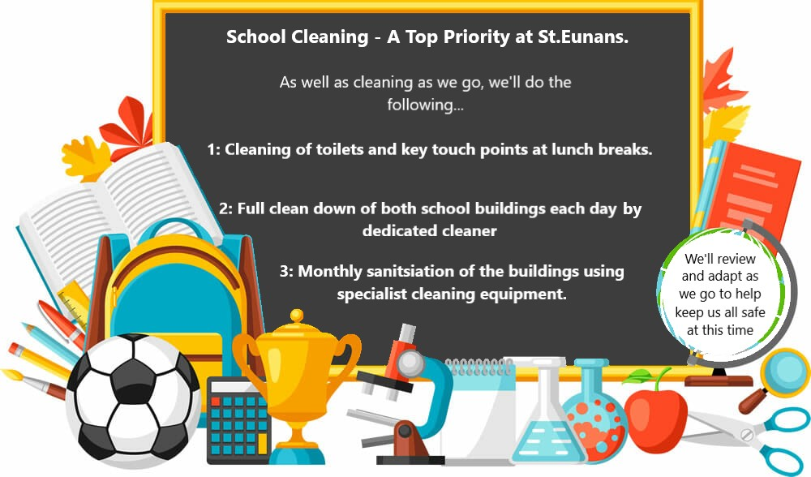

- Signage/Posters:
to remind pupils, parents and staff of COVID-19 symptoms will be displayed in each classroom and throughout the school and on the parents’ notice board. In addition, posters will be displayed to remind us all of the importance of hand washing, sneezing and coughing etiquette. The content of these posters will be taught and retaught to all pupils on an ongoing basis.

- Masks/visors

  - It is not recommended that children attending primary school wear face coverings.

  - It is recommended that staff in primary schools wear a face-covering. Staff in our school will wear face coverings.

- Ventilation

Windows will be open throughout the day to ensure proper circulation of air throughout classrooms and corridors within the school. Please ensure that your child wears extra layers so that they are comfortable throughout the day.

- Process for dealing with a suspected case of COVID 19:
A designated isolation room will be used for any pupil or staff member who begins to show symptoms of COVID-19 during the school day. The pupil or staff member will be given a facial mask. In the case of a pupil showing symptoms, parents will be contacted and will be asked to collect their child as soon as possible.

School staff are very much looking forward to welcoming your child back to school on 1st March / 15th March 2021.

We would like to thank parents teachers and the entire school community for all their hard work throughout the closure.

Please contact me at steunansprincipal@gmail.com if you have any concerns or questions.

Yours sincerely,

Anita Keeve

11

